

**Genomic Health**

.  
.  
.  
.  
.  
..  
.  
.  
.

Business Requirement Specifications for Domestic  
Portal & Online Ordering

Document Number: BRS-OP-PA-05-003

Revision Number: 4.0

Effective Date:

The following reviewers have approved this document.

See DCO for approver signatures and dates.

|  |
| --- |
| **Name and Department** |
| **Stephen Adams**  **AUTHOR, COMMERCIAL OPERATIONS PLANNING** |
| **Leslie Marquez**  **CUSTOMER SERVICE & ACCESSIONING** |
| **Angela Tzagarakis**  **INTERNATIONAL CUSTOMER SERVICE** |
| **Bill Haack**  **SALES OPERATIONS** |
| **Sonya Natanzon**  **SOFTWARE ENGINEERING** |
| **Robert Gupta**  **SOFTWARE ENGINEERING** |
| **Tam Vo**  **QUALITY ENGINEERING** |
| **Kathleen Determann**  **LEGAL** |
| **Karen Cavanaugh**  **PRODUCT MANAGEMENT** |
| **Michael Hicks**  **U.S. SALES & MARKETING** |
| **Stephanie Butler**  **COMMERCIAL OPERATIONS PLANNING  & REGULATORY (CLIA)** |
| **Julie Ballard, CLS or Rory O’Brien, CLS**  **CLINICAL LABORATORY QA** |
| **Patrick Joseph, M.D.**  **CLINICAL LABORATORY DIRECTOR** |
| **DCO-BRS-OP-PA-05-003-4** |

**TABLE OF CONTENTS**

[1 Introduction 5](#_Toc303757497)

[1.1 Document Objectives & Scope 5](#_Toc303757498)

[1.2 Definitions and Acronyms 5](#_Toc303757499)

[1.3 Related Documents 7](#_Toc303757500)

[1.4 Styles Used in This Document 7](#_Toc303757501)

[2 General content requirements 7](#_Toc303757502)

[2.1 Website Look and Feel 7](#_Toc303757503)

[2.2 GHI Logos 7](#_Toc303757504)

[2.3 Page Header 8](#_Toc303757505)

[2.4 Page Footer 8](#_Toc303757506)

[2.5 Customer Service Contact Box 8](#_Toc303757507)

[2.6 Browser Window Title & Banner Title 8](#_Toc303757508)

[2.7 Navigation Controls 9](#_Toc303757509)

[3 User Login & Security 9](#_Toc303757510)

[3.1 Account Creation Email 9](#_Toc303757511)

[3.2 Accessing the Portal 10](#_Toc303757512)

[3.3 User Login Page 10](#_Toc303757513)

[3.4 User Login Page – Error Messages 11](#_Toc303757514)

[3.5 Change Password – Initial Setup 11](#_Toc303757515)

[3.6 Password Changed – Success 12](#_Toc303757516)

[3.7 Security Questions – Initial Setup 13](#_Toc303757517)

[3.8 Security Questions - Content 14](#_Toc303757518)

[3.9 Update Security Questions 14](#_Toc303757519)

[3.10 Password Reset Feature 15](#_Toc303757520)

[3.10.1 Reset Your Password – User Information Tab 15](#_Toc303757521)

[3.10.2 Reset Your Password – Security Questions Tab 16](#_Toc303757522)

[3.10.3 Reset Your Password – Reset Password Tab 17](#_Toc303757523)

[3.10.4 Reset Your Password – Confirmation Page 18](#_Toc303757524)

[3.10.5 Reset Your Password – Email Messages to the User 18](#_Toc303757525)

[3.10.6 Reset Your Password – Error Messages 19](#_Toc303757526)

[3.11 Username Recovery Feature 20](#_Toc303757527)

[3.11.1 Forgot Your Username – User Information Page 20](#_Toc303757528)

[3.11.2 Forgot Your Username – Confirmation Page 21](#_Toc303757529)

[3.11.3 Forgot Your Username – Email Message to the User 22](#_Toc303757530)

[4 Home Page 23](#_Toc303757531)

[4.1 Alerts & Announcements 24](#_Toc303757532)

[4.1.1 Alerts 24](#_Toc303757533)

[4.1.2 Announcements 24](#_Toc303757534)

[4.2 Start Continue Order 24](#_Toc303757535)

[4.3 Recent Orders 24](#_Toc303757536)

[5 Orders Page 24](#_Toc303757537)

[5.1 Submitted Orders 27](#_Toc303757538)

[5.2 Completed Orders 27](#_Toc303757539)

[6 Order DEtails 27](#_Toc303757540)

[6.1 Order Details 29](#_Toc303757541)

[7 Online Ordering 30](#_Toc303757542)

[7.1 Start/Continue Order Page 30](#_Toc303757543)

[7.1.1 Order in Progress 31](#_Toc303757544)

[7.2 New Order Test Type 32](#_Toc303757545)

[7.2.1 Oncotype DX - Breast 32](#_Toc303757546)

[7.2.2 Oncotype DX - Colon 32](#_Toc303757547)

[If the customer selects the colon assay, the following test type options will appear: 32](#_Toc303757548)

[▪ Sequential Assays: MMR then Onco*typ*e DX Colon Cancer if MMR is Proficient 32](#_Toc303757549)

[7.3 Navigation 34](#_Toc303757550)

[7.4 Patient Tab - Breast 34](#_Toc303757551)

[7.4.1 Clinical Information - Breast 34](#_Toc303757552)

[7.4.1.1 Node Status 35](#_Toc303757553)

[7.4.1.2 ER Status 35](#_Toc303757554)

[7.5 Patient Tab – Colon 36](#_Toc303757555)

[7.5.1 Clinical Information – Colon 36](#_Toc303757556)

[7.5.2 Clinical Information 36](#_Toc303757557)

[Remove MSI-High so the statement reads “MMR-Deficient”. Not visible for MMR orders. 36](#_Toc303757558)

[The clinical information required is dependant on the customers test type selection. 36](#_Toc303757559)

[7.6 Multiple Primaries 37](#_Toc303757560)

[7.7 Recommended Information – Breast & Colon 38](#_Toc303757561)

[7.8 Online Ordering – Billing Tab 38](#_Toc303757562)

[7.8.1 ICD-9 Codes 39](#_Toc303757563)

[7.8.1.1 Breast - DCIS ICD-9 Codes 39](#_Toc303757564)

[7.8.1.2 Breast – Invasive Breast Cancer ICD-9 Codes 39](#_Toc303757565)

[7.8.1.3 Colon – All Colon Assays 40](#_Toc303757566)

[• 153.5 – Malignant neoplasm of appendix 40](#_Toc303757567)

[7.8.2 Private Insurance (US Carriers Only)/ Medicaid 41](#_Toc303757568)

[7.8.3 Medicare 42](#_Toc303757569)

[7.8.4 Patient Self-Pay – Credit Card 42](#_Toc303757570)

[7.8.5 Bill Account 43](#_Toc303757572)

[7.8.6 Uninsured Patient 44](#_Toc303757573)

[7.8.7 CARE Survey – for Colon Only 45](#_Toc303757574)

[7.9 Online Ordering – Options Tab 45](#_Toc303757575)

[7.9.1 Benefits Investigation 47](#_Toc303757576)

[7.9.2 Specimen Retrieval 48](#_Toc303757577)

[7.10 Online Ordering – Physician Tab 48](#_Toc303757578)

[7.11 Online Ordering – Review Page 50](#_Toc303757579)

[7.11.1 Physician Signature 52](#_Toc303757580)

[7.11.2 Online Ordering – Error Checking 52](#_Toc303757581)

[7.12 Online Ordering – Order Confirmation 52](#_Toc303757582)

[7.13 Online Ordering – Email Notifications 53](#_Toc303757583)

[7.14 Online Ordering – FAX Cover Sheet 54](#_Toc303757584)

[8 Address Book & My Account 54](#_Toc303757585)

[8.1 Address Book 55](#_Toc303757586)

[8.2 Address Book – Add/Edit Contact 56](#_Toc303757587)

[8.3 Address Book – Add/Edit Location 57](#_Toc303757588)

[9 My Account 58](#_Toc303757589)

[9.1 My Account 58](#_Toc303757590)

[9.2 Change Password 59](#_Toc303757591)

[9.3 Update Security Questions 59](#_Toc303757592)

[9.4 My Locations & Delegate Management 60](#_Toc303757593)

[10 Archives 60](#_Toc303757594)

[11 Contact Us Page 61](#_Toc303757595)

[12 Report Email Notification from Portal 62](#_Toc303757596)

[13 Online Help Pages 63](#_Toc303757597)

[13.1 Help Index 63](#_Toc303757598)

[Welcome to Genomic Health Online Portal Help 63](#_Toc303757599)

[Oncotype DX® Process 63](#_Toc303757600)

[What does this status mean? 63](#_Toc303757601)

[What do the icons mean? 64](#_Toc303757602)

[How do I contact Genomic Health’s Customer Service? 64](#_Toc303757603)

[Self-Service Tools 64](#_Toc303757604)

[Privacy Notice 64](#_Toc303757605)

[13.2 How to Order 65](#_Toc303757606)

[How do I order the Oncotype DX assay? 65](#_Toc303757607)

[How to Order Oncotype DX 65](#_Toc303757608)

[Helpful Hints 65](#_Toc303757609)

[Order Supplies/Questions 69](#_Toc303757610)

[13.3 How to Submit a Specimen 69](#_Toc303757611)

[13.3.1 Oncotype DX Specimen Types 70](#_Toc303757612)

[13.3.2 Oncotype DX Specimen Preparation Instructions (click to view): 70](#_Toc303757613)

[13.3.3 Oncotype DX Specimen Collection and Transportation Kit Box 71](#_Toc303757614)

[• Oncotype DX Specimen Kit containing the patient specimen, pathology report and Oncotype DX Requisition Form. 71](#_Toc303757615)

[13.4 Health Insurance Coverage 73](#_Toc303757616)

[14 Legal & Regulatory Requirements 74](#_Toc303757617)

[14.1 Clinical Terms of Use (TOU) 74](#_Toc303757618)

[14.2 YOU ACKNOWLEDGE THAT YOU HAVE READ GENOMIC HEALTH’S TOU AGREEMENT AND UNDERSTAND IT. BY PRESSING “I Agree” BELOW, YOU CONSENT TO BE BOUND BY THESE TOU. 80](#_Toc303757619)

[14.3 Non-Clinical Terms of Use (TOU) 80](#_Toc303757620)

[14.4 Delegate Attestation 84](#_Toc303757621)

[14.5 Physician’s Electronic Signature 85](#_Toc303757622)

[14.5.1 Breast 85](#_Toc303757623)

[14.5.2 Colon 86](#_Toc303757624)

[15 Other Requirements 86](#_Toc303757625)

[15.1 Standard Operating Procedures 86](#_Toc303757626)

[15.2 Training 86](#_Toc303757627)

[15.3 User Testing and User Acceptance Testing 87](#_Toc303757628)

[16 Appendix A – Portal Release History 88](#_Toc303757629)

# Introduction

This document contains the content requirements for the Genomic Health, Inc.® (GHI) Portal and Domestic Online Ordering website.

The Online Portal Website consists of the following modules:

1. Online Ordering
2. Address Book, including contact and location management tools
3. Document Archives
4. Announcements and Alerts
5. Online Help

The Online Ordering module, which is the major focus of Online Portal, allows physicians and their delegates to order Onco*type* DX® Breast and Colon tests on the Web by completing an electronic requisition form and submitting it to GHI for processing. Users are guided through a series of web pages designed to fill in logical sections of the Requisition Form. Incomplete orders can be saved and finished at a later time. The software performs data validation at various stages of the order entry process. Completed orders will be available to the user (as a PDF file) for printing and viewing.

Initially orders will only be visible to the user who initiated the creation of the order. Once the order is entered into SARP, it will be visible to the sponsor, and by extension, to all delegates of the ordering physician.

Portal Manager software allows authorized users to manage user accounts, upload documents to specific users and groups, view/edit/delete submitted and incomplete online orders, view Portal events, and view the audit trail for Portal database tables.

Speaker Portal provides a multi-faceted resource center for key opinion leaders (KOL) and contracted speakers to access information about Genomic Health, Inc. (GHI) products. The Speaker Portal website contains new, archived, and customizable presentations, including Slide Decks, Multimedia Presentations, and Case Studies.

Speaker Portal Manager allows authorized administrators to add, edit, and delete content files from the website and perform other administrative functions.

## Document Objectives & Scope

The objective of this document is to define the content requirements of the Portal and Domestic Online Ordering website from the perspective of the user.

The intended audience for this document includes Software Engineering, Software Quality Assurance, Commercial Operations, Customer Support, Marketing, Legal, Regulatory, and all project team members.

This document does not describe any engineering or project management details.

## Definitions and Acronyms

| **Acronym/Term** | **Definition** |
| --- | --- |
| BI | Benefits Investigation |
| Contact | A contact person in Portal, including physicians, nurses, administrators, etc. |
| CRM System | Customer Relationship Management System. The system used primarily by Sales and Customer Service to manage accounts, orders, and communications with customers. |
| CRS | A Customer Relations Specialist (CRS) is a member of the GHI staff who is employed to handle customer service requests. This definition encompasses both full time Customer Service representatives as well as other members of the GHI staff who are trained as CSRs in an overflow capacity. |
| CS | Customer Service |
| CSSR | Customer Service Support Representative |
| Delegate | A person authorized by the Sponsor to receive access to the Sponsor’s reports, and request diagnostic tests ordered by the Sponsor as allowed by local, state, and federal laws, through the GHI Online Portal. A person may act as Delegate for more than one physician, as might be helpful in a group practice. |
| DOB | Date of Birth |
| ER | Estrogen Receptor |
| ERD | Estimated Report Date (also known as ESD) |
| ESD | Estimated Ship Date (also known as ERD) |
| FAP | Financial Assistance Program |
| GHI | Genomic Health, Inc. |
| KOL | Key Opinion Leaders |
| MA | Medical Assistant |
| NP | Nurse Practitioner |
| Online Portal Account | User Account for the Genomic Health Online Portal System. |
| PA | Prior Authorization |
| PAB | Personal Address Book |
| PAN | Primary Account Number for a credit card account |
| PCI | Payment Card Industry |
| PHA | Physician Assistant |
| PHI | Protected Health Information |
| Portal Administrator | A member of the Genomic Health Information Systems staff who is responsible for responding to service requests relating to the Online Portal. |
| SAT | Sample Accessioning Technician – a role within Customer Service |
| SOP | Standard Operating Procedure |
| Sponsor | A person [typically a Physician, Physician Assistant (PHA), or Nurse Practitioner (NP)] who has requested and been granted a GHI Online Portal account. This person may access their patient reports (those for which they have been listed as a physician) and order diagnostic tests using the Online Portal. This person may also authorize Delegates to access their patient reports, and request diagnostic tests ordered by the Sponsor, through the GHI Online Portal. |
| SSN | Social Security Number |

## Related Documents

|  |  |
| --- | --- |
| **Document Number** | **Document Name** |
| ERD-OP-IT-05-019-N | Requirements Specification for Portal and Online Ordering |
| EDD-OP-IT-05-019-N | Design Specification for Portal and Online Ordering |
| ERD-OP-IT-05-019-O | Requirement Specification for Speaker Portal |
| EDD-OP-IT-05-019-O | Design Specification for Speaker Portal |
| SOP-OP-PA-03-001 | Requisition Processing |
| SOP-OP-PA-03-019 | Online Ordering Requisition Processing |
| SOP-CO-GA-02-007 | Approval and Use of Promotional, Public, and Competitive Statements |
| SOP-OP-PA-03-014 | Managing Online Portal Accounts |

## Styles Used in This Document

The following styles are used in this document:

* Exact text that will be presented to the user is in orange.
* Explanatory text that provides more information about the content requirements is in **black**.

# General content requirements

|  |  |  |
| --- | --- | --- |
| **CONTENT**  **OWNERS** | **Department** | **Responsible Person** |
| Software Engineering | Sonya Natanzon |
| Commercial Operations | Stephen Adams |
| **PURPOSE** | The master web page layout for Portal provides a consistent look and feel throughout the application for our customers. The navigation controls provide a consistent way of moving through the website. | |

## Website Look and Feel

* The pages within the Portal website will have a consistent look and feel.
* The corporate color scheme and product-specific color schemes will be used throughout the website.

## GHI Logos

Genomic Health Generic Onco*type* DX Logo



Genomic Health Onco*type* DX – Breast Cancer Assay Logo



Genomic Health Onco*type* DX – Colon Cancer Assay Logo



## Page Header

The header of every page on the website will contain the following elements:

* User’s name in “First Last” format
* Link to “My Account” page
* Link to main Help page
* Link to Contact Us
* Link that logs out the user



## Page Footer

The footer of every page on the website will contain the following elements:

* Copyright statement
* Link to main Help page
* Link to main Privacy page
* Link to the Terms of Use page (except on the Terms of Use page itself)



## Customer Service Contact Box

A few pages on the website will have the Customer Service phone number and a link to the secure Customer Service Email page.

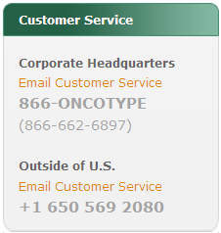

**Corporate Headquarters**

Email Customer Service

866-ONCOTYPE

(866-662-6897)

**Outside of U.S.**

Email Customer Service

+1 650 569 2080

## Browser Window Title & Banner Title

* The browser window title and the website banner title will be the same.
* The browser window title will also contain the text: Genomic Health Online

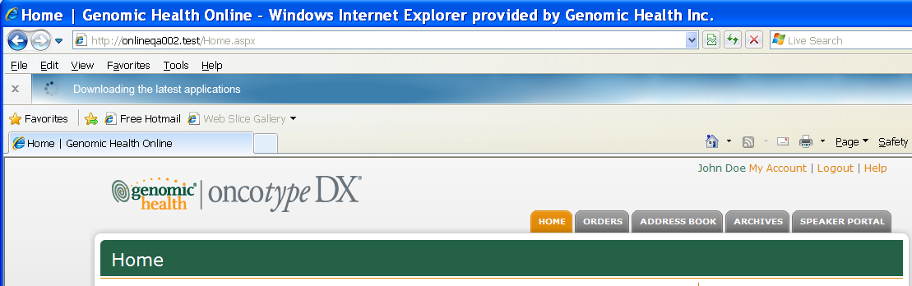

Browser window title

Banner title

## Navigation Controls

Users will navigate through the application using the tab controls, which are labeled as follows:



# User Login & Security

|  |  |  |
| --- | --- | --- |
| **CONTENT**  **OWNERS** | **Department** | **Responsible Person** |
| GHI Chief Security Officer | Ken Stineman |
| Commercial Operations | Stephen Adams |
| **PURPOSE** | The user login page provides security to the application and the GHI network. Only authorized users are allowed to log in and access the functionality provided by Online Portal. | |

## Account Creation Email

Upon receiving an account creation request Customer Service will email the User ID and temporary password to the new user with the following CRM template.

Dear…

Per your request, we have created an on-line account for viewing your future Oncotype DX™ results reports.  Your account ID and password are as follows:

Account ID:    
Password:

When your results are ready for viewing, you will receive an email from the Genomic Health laboratory. To access your reports, use the following web-link:

<https://online.genomichealth.com/Login.aspx>

Should you wish any of your office or nursing staff to have online access to your patients' Oncotype DX™ results, please submit a signed or verbal request to Customer Service complete with contact information and email address. We will gladly create a delegate account upon receipt of this information.

Please feel free to contact us at the phone number listed below if you have any questions.

Best regards,

Customer Service  
Genomic Health, Inc.  
[www.oncotypedx.com](http://www.oncotypedx.com)  
[www.genomichealth.com](http://www.genomichealth.com)

## Accessing the Portal

Users can access the portal using the link provided in the account setup email sent by Customer Service. Users are also instructed to save the website in the “Favorites” of their web browser. A Portal shortcut can be saved to their desktop. The Portal shortcut icon is below:



## User Login Page

Users can access the homepage using the link sent to them by Customer Service within the User Name and Login information email.

The **User Login** page looks like this:

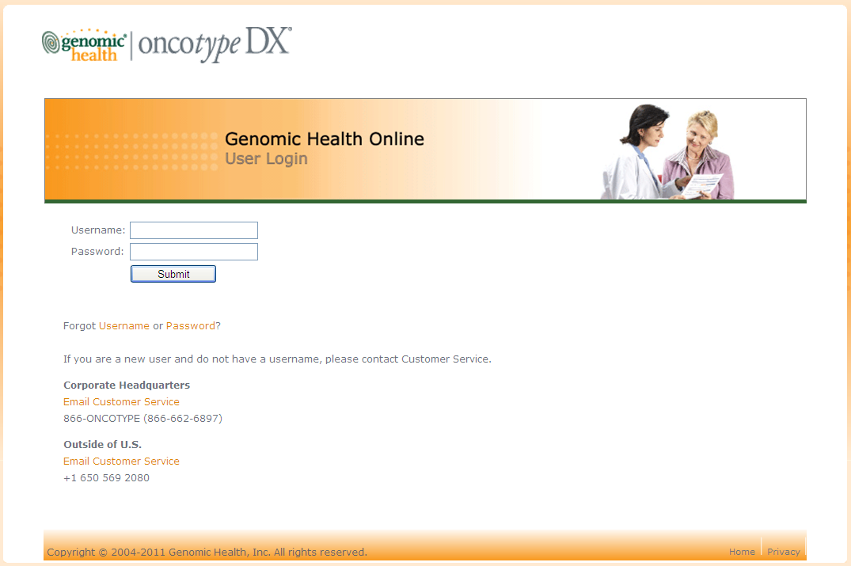

If you are a new user and do not have a username, please contact Customer Service.

**Corporate Headquarters**

Email Customer Service

866-ONCOTYPE (866-662-6897)

**Outside of U.S.**

Email Customer Service

+1 650 569 2080

## User Login Page – Error Messages

|  |  |  |
| --- | --- | --- |
| **User Login Page – Error Messages** | | |
| **#** | **Error Condition** | **Error Message** |
| 1 | The user clicked the Logout link in the header of any Portal page. | You have been logged out. |
| 2 | The user left his/her computer unattended for longer than the defined Portal timeout period.  Currently, the timeout is 30 minutes. | You have been logged out. |
| 3 | The user left the Username field blank. | Username must be supplied. |
| 4 | The user left the Password field blank. | Password must be supplied. |
| 5 | The user entered invalid information in one of the fields on the User Login page. | Username or password is not valid. |

## Change Password – Initial Setup

New users must initially change the password provided to them by customer service. While doing so the new password security requirements must be met.

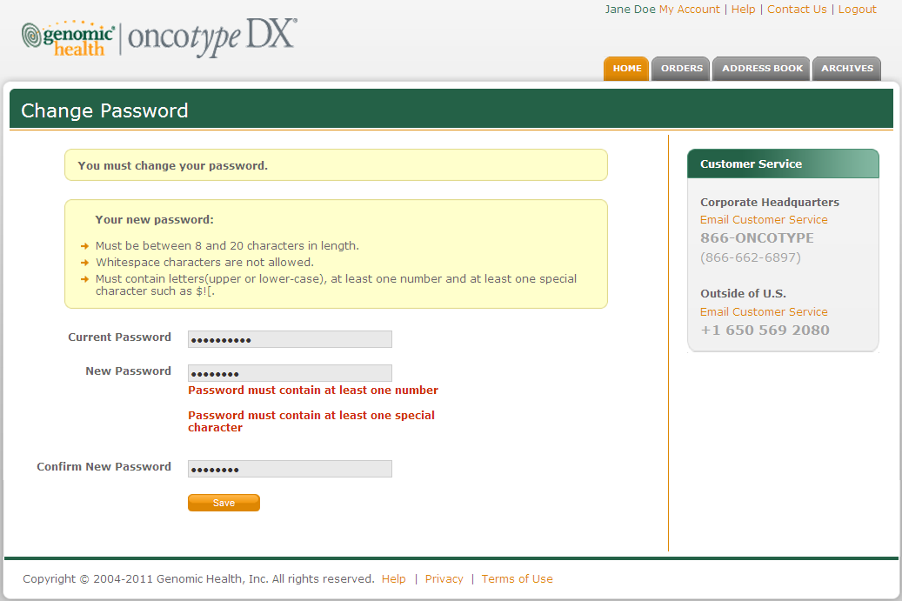

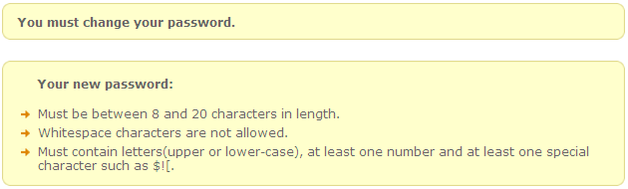

Your new password:

* Must be between 8 and 20 characters in length.
* Whitespace characters are not allowed.
* Must contain letters (upper or lower-case), at least one number and at least one special character such as $![.

## Password Changed – Success

Once the security requirements are met, the password is changed and the user is permitted to continue.

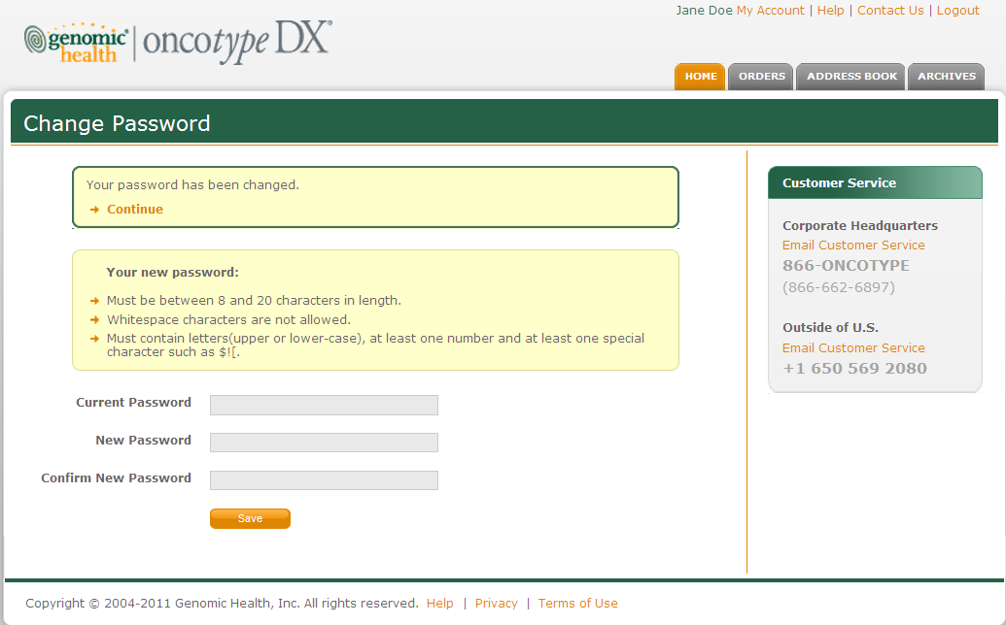

## Security Questions – Initial Setup

New users will be required to set up three security questions when they first log in to Portal within the **My Security Questions** – **Create Security Questions** page.

| **My Security Questions Page - Content** | |
| --- | --- |
| **Field or Object** | **Label/Content** |
| Browser window title | My Security Questions |
| Banner title | My Security Questions |
| Page subtitle | CREATE SECURITY QUESTIONS |

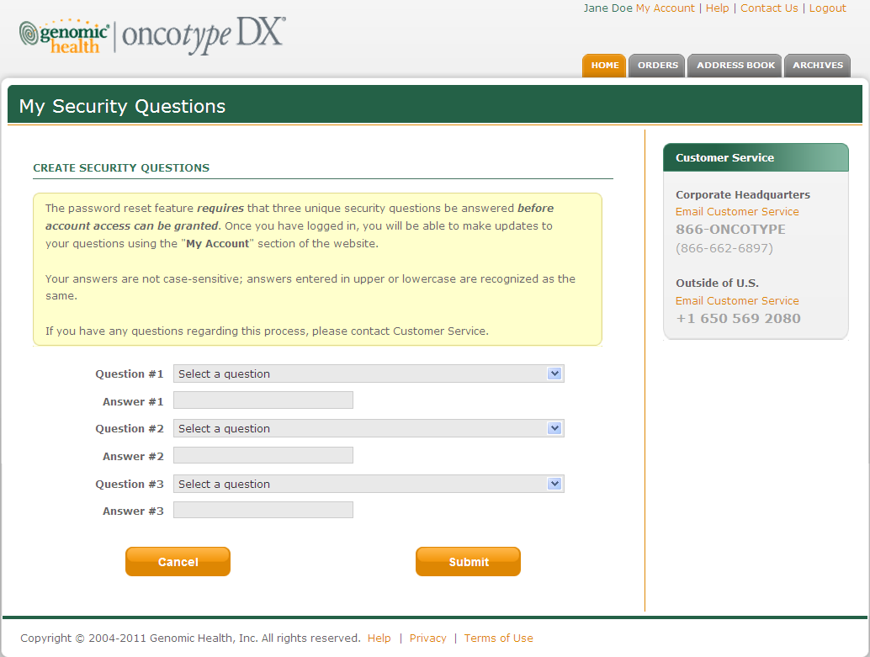

The following setup instructions will be displayed on the **My Security Questions** page in a yellow box:

The password reset feature ***requires*** that three unique security questions be answered ***before account access can be granted***. Once you have logged in, you will be able to make updates to your questions using the **"My Account"** section of the website.

Your answers are not case sensitive; answers entered in upper or lowercase are recognized as the same.   
  
 If you have any questions regarding this process, please contact Customer Service.

## Security Questions - Content

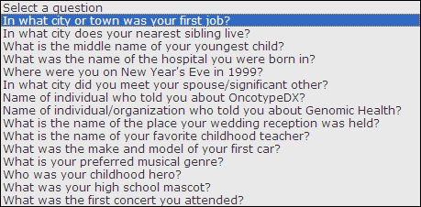

## Update Security Questions

The user can update their security questions at any time on the **My Account** page.

| **My Account Page - Content** | |
| --- | --- |
| **Field or Object** | **Label/Content** |
| Browser window title | My Account |
| Banner title | My Account |
| Page subtitle | Update Security Questions |

The **My Account** page contains a section entitled **Update Security Questions** that will look like this:

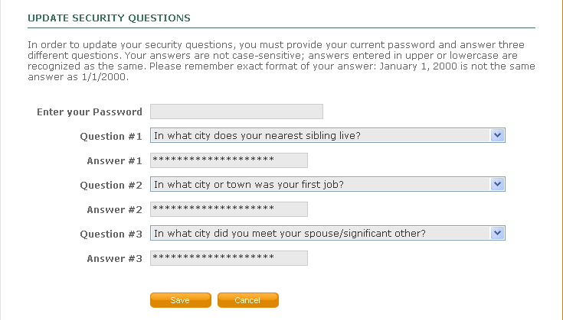

**Instruction text:**

In order to update your security questions, you must provide your current password and answer three different questions.Your answers are not case-sensitive; answers entered in upper or lowercase are recognized as the same.

**Confirmation message:** Your security questions have been updated.

## Password Reset Feature

The user can access this feature from the Login screen..

### Reset Your Password – User Information Tab

| **Reset Your Password - Content** | |
| --- | --- |
| **Field or Object** | **Label/Content** |
| Browser window title | Reset your password |
| Banner title | Reset your password |
| Page subtitle | Enter your User Information |

The **Reset your password** page contains four tab controls. The first tab is entitled **User Information** and looks like this:

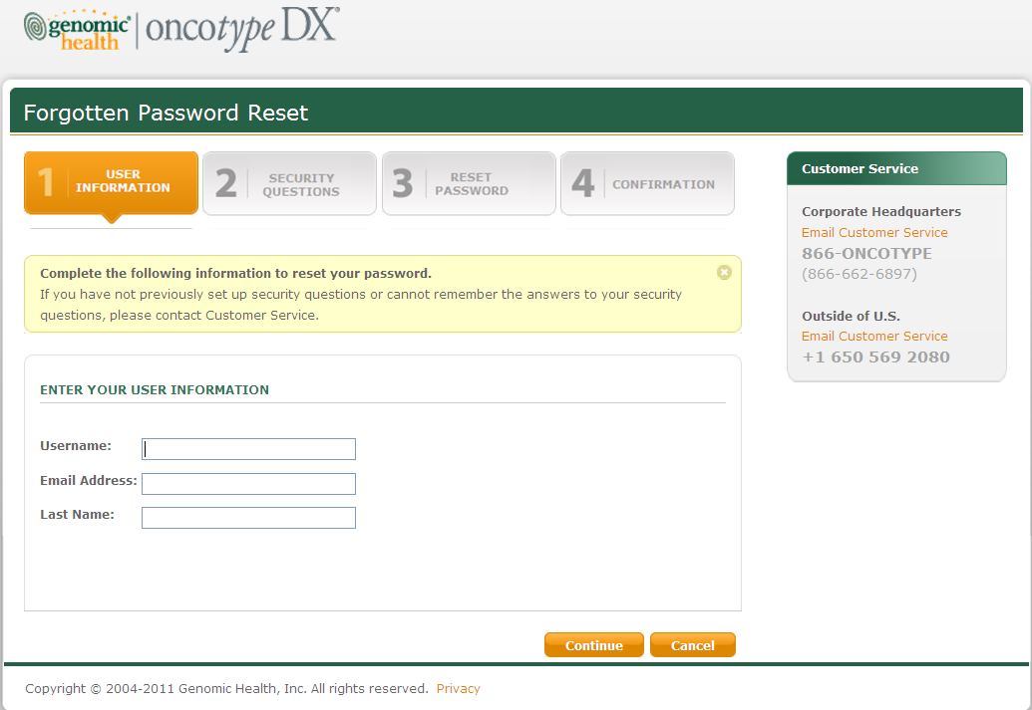

The following fixed text will appear in a yellow box that can be closed by the user, if desired.

**Complete the following information to reset your password.**

If you have not previously set up security questions or cannot remember the answers to your security questions, please contact Customer Service.

### Reset Your Password – Security Questions Tab

The second tab control on the **Reset your password** page is labeled **Security Questions** and looks like this:

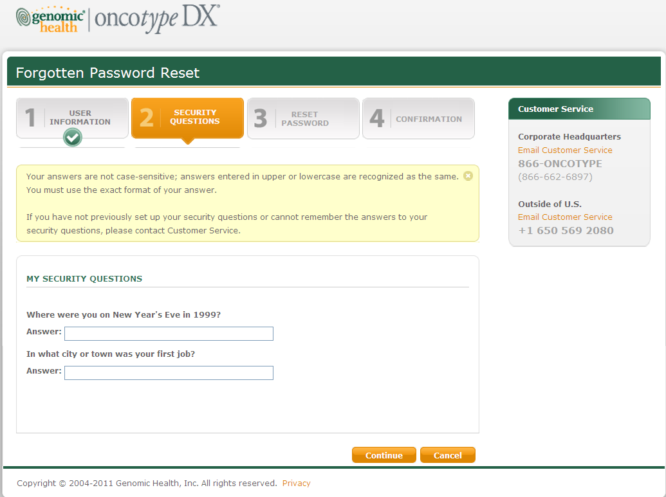

The following fixed text will appear in a yellow box that can be closed by the user, if desired:

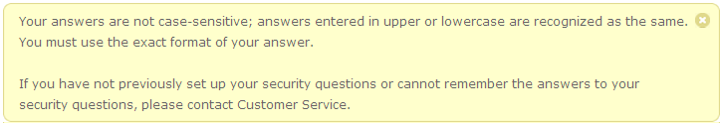

Your answers are not case-sensitive; answers entered in upper or lowercase are recognized as the same. You must use the exact format of your answer..

If you have not previously set up your security questions or cannot remember the answers to your security questions, please contact Customer Service.

### Reset Your Password – Reset Password Tab

The third tab control on the **Reset your password** page is labeled **Reset Password** and looks like this:

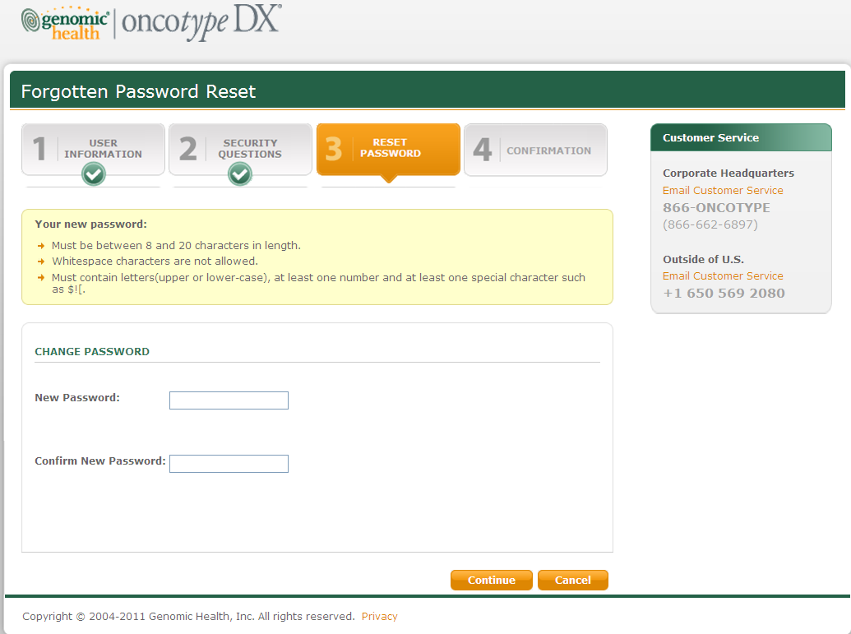

The following fixed text will appear in a yellow box that can be closed by the user, if desired:

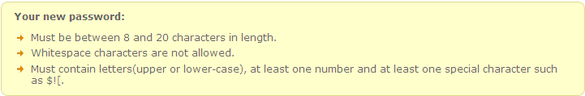

### Reset Your Password – Confirmation Page

The fourth tab control on the **Reset your password** page is labeled **CONFIRMATION** and looks like this:

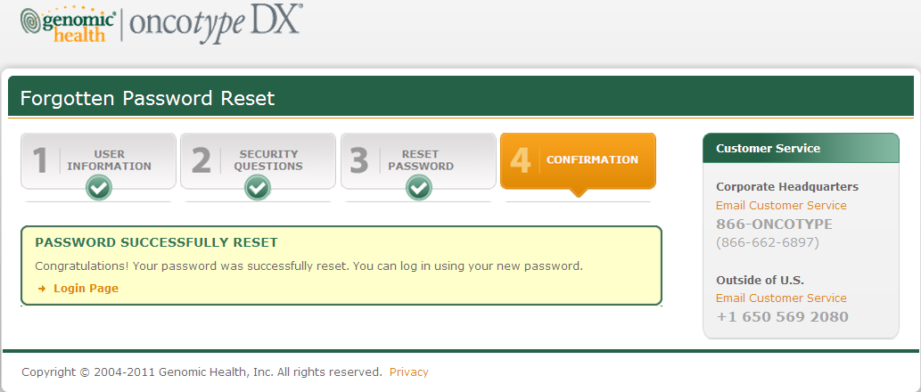

The following fixed text will appear in a yellow box that can be closed by the user, if desired:

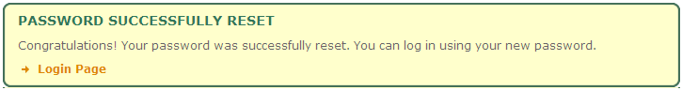

PASSWORD SUCCESSFULLY RESET

Congratulations! Your password was successfully reset. You can login using your new password.

* Login Page [URL will be a link to the login page]

### Reset Your Password – Email Messages to the User

**Successful Password Change**

A confirmation Email message will be sent to the user upon successful completion of the Reset Password function. The Email will contain the following text:

Dear (Full Name),

You have successfully reset your password with Genomic Health Online Portal. If you did not change your password, or if you have any questions, please contact Customer Service immediately.

**Corporate Headquarters**

customerservice@genomichealth.com

866-ONCOTYPE

(866-662-6897)

**Outside of U.S.**

international@genomichealth.com

+1 650 569 2080

To visit the Genomic Health Online Portal, please go to <https://online.genomichealth.com>

Please do not reply to this message, it was sent from an unmonitored email address. You are receiving this email because you are a registered user of Genomic Health Online Portal.

Privacy: http://www.genomichealth.com/privacy.aspx

**Unsuccessful Password Change**

An Email message will be sent to the user if a failed attempt is made to change the password. The text of the message is as follows:

Dear (Full Name),

A failed attempt has been made to reset your password on the Genomic Health Online Portal. If you did not attempt to change your password, please contact Customer Service immediately.

**Corporate Headquarters**

customerservice@genomichealth.com

866-ONCOTYPE

(866-662-6897)

**Outside of U.S.**

international@genomichealth.com

+1 650 569 2080

To visit the Genomic Health Online Portal, please go to <https://online.genomichealth.com>

Please do not reply to this message, it was sent from an unmonitored email address.

You are receiving this email because you are a registered user of Genomic Health Online Portal.

Privacy: http://www.genomichealth.com/privacy.aspx

### Reset Your Password – Error Messages

|  |  |  |
| --- | --- | --- |
| **Reset Your Password – Error Messages** | | |
| **Tab** | **Error Condition** | **Error Message** |
| 1 | The user entered incorrect information on the **User Information** tab. | The information entered is incorrect, please contact Customer Service for assistance. |
| The user entered incorrect information on the **User Information** tab.  **Note to Customer Service**: this may mean that more than one user has the same combination of Last Name and Email address. | For your protection and security, you cannot continue due to invalid information entered above.  If this problem persists, please contact Customer Service. |
| The user did not enter his/her username on the **User Information** tab. | Username must be supplied. |
| The user did not enter an Email address on the **User Information** tab. | Email address must be supplied. Invalid email address format. |
| The user entered an invalid Email address on the **User Information** tab. | Invalid email address format. |
| The user did not enter a last name on the **User Information** tab. | Last name must be supplied. |
| 2 | The user entered the wrong answer for either question on the **Security Questions** tab. | You may have entered one or more incorrect answers. Please try again.  If this problem persists, please contact Customer Service. |
| 3 | The user did not fill out one or more fields on the **Reset Password** tab. | Password must be supplied. |
| The user entered incorrect information on the **Reset Password** tab. | Must be 8-20 characters (no spaces)  Password must contain upper and lower-case letters  Password must contain at least one special character |
| The user entered a different password in each of the fields on the **Reset Password** tab. | Passwords do not match. We cannot complete this operation at this time, please contact Customer Service for assistance. |

## Username Recovery Feature

The user can access this feature from the Login screen or from My Account after logging in.

### Username Recovery – User Information Page

| **Username Recovery** | |
| --- | --- |
| **Field or Object** | **Label/Content** |
| Browser window title | Username Recovery |
| Banner title | Username Recovery |
| Page subtitle | Username Request Instructions |

The first tab control on the Username Recoverypage is labeled **User Information** and looks like this:

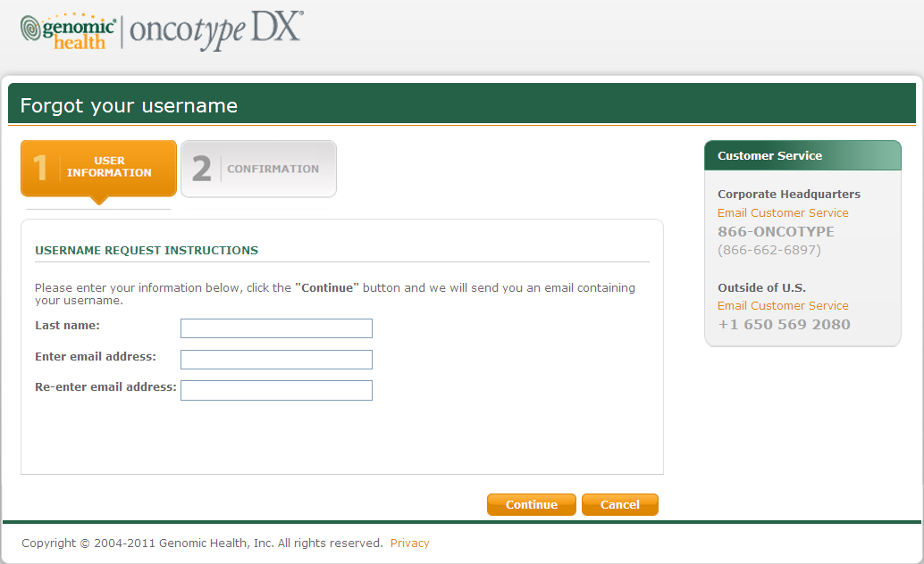

**Instruction text:**

Please enter your information below, click the **"Continue"** button and we will send you an email containing your username.

### Forgot Your Username – Confirmation Page

| **Username Recovery - Content** | |
| --- | --- |
| **Field or Object** | **Label/Content** |
| Browser window title | Username Recovery |
| Banner title | Username Recovery |

The second tab control on the **Username Recovery** page is labeled **Confirmation** and looks like this:

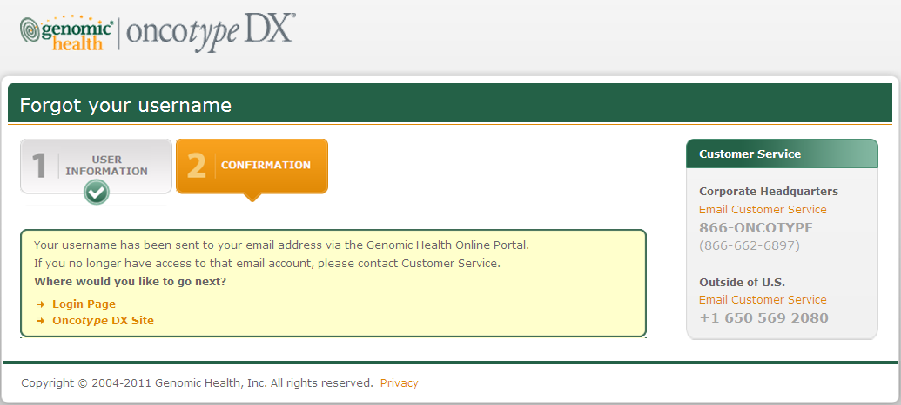

Your username has been sent to your email address via the Genomic Health Online Portal.

If you no longer have access to that email account, please contact Customer Service.

**Where would you like to go next?**

* Login Page
* Oncotype DX Site

### Username Recovery – Email Message to the User

If data entry is correct, the user will receive the following email:

Dear [FirstName LastName],   
  
In response to your request to be reminded of your Genomic Health Online Portal username, please find below the information we have on file for you. If you did not submit this request, please contact Customer Service.  
Your username is: [Username]

Your registered email address is: [EmailAddress]

If you have forgotten your password, you can reset it at: <https://online.genomichealth.com/PasswordReset.aspx>

If you have any questions regarding this email, please contact Customer Service.

**Corporate Headquarters**

customerservice@genomichealth.com

866-ONCOTYPE

(866-662-6897)

**Outside of U.S.**

international@genomichealth.com

+1 650 569 2080

Please do not reply to this message, it was sent from an unmonitored email address.

You are receiving this email because you are a registered user of Genomic Health Online Portal.

Privacy: http://www.genomichealth.com/privacy.aspx

### Username Recovery – Error Messages

|  |  |  |
| --- | --- | --- |
| **Username Recovery – Error Messages** | | |
| **Tab** | **Error Condition** | **Error Message** |
| 1 | The user entered incorrect information on the **User Information** tab. | Unable to locate any account that matched the information you provided. |

# Home Page

|  |  |  |
| --- | --- | --- |
| **CONTENT**  **OWNERS** | **Department** | **Responsible Person** |
| Commercial Operations | Stephen Adams |
| Marketing | Karen Cavanaugh |
| **PURPOSE** | The Online Ordering feature allows authorized users to place Oncotype DX – Breast and Oncotype DX – Colon orders online. | |

| **Home Page - Content** | |
| --- | --- |
| **Field or Object** | **Label/Content** |
| Browser window title | Home |
| Banner title | Home |

Upon logging in, the user sees the first tab control labeled **Home**

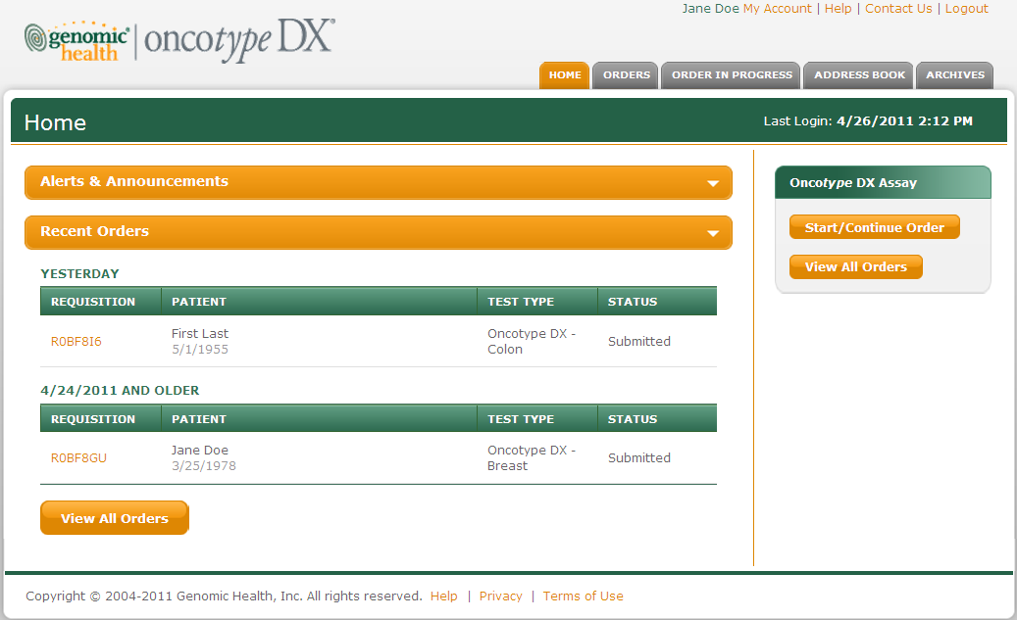

## Alerts & Announcements

Alerts are specific to the user. Announcements are for all portal users. When Alerts are displayed they are grouped into categories by date, such as TODAY and/or YESTERDAY.

### Alerts

Alerts are specific to the user, such as a report ready for download.

### Announcements

Announcements are for all portal users. No Announcement will be displayed for the Tel-Aviv release.

## Start Continue Order

The Start/Continue Order button is only visible to users who are an ordering entity. To become an ordering entity users must contact Customer Service.

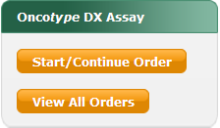

## Recent Orders

Recent Orders displays a list of all orders placed by a user within the past 2 weeks and displays the following information.



# Orders Page

|  |  |  |
| --- | --- | --- |
| **CONTENT**  **OWNERS** | **Department** | **Responsible Person** |
| Commercial Operations | Stephen Adams |
| Customer Service | Leslie Marquez |
| **PURPOSE** | The Orders page will display all orders (both submitted and completed) for the current user. | |

| **Orders Page - Content** | |
| --- | --- |
| **Field or Object** | **Label/Content** |
| Browser window title | Orders |
| Banner title | Orders |

The second tab control is labeled **Orders** and looks like this:

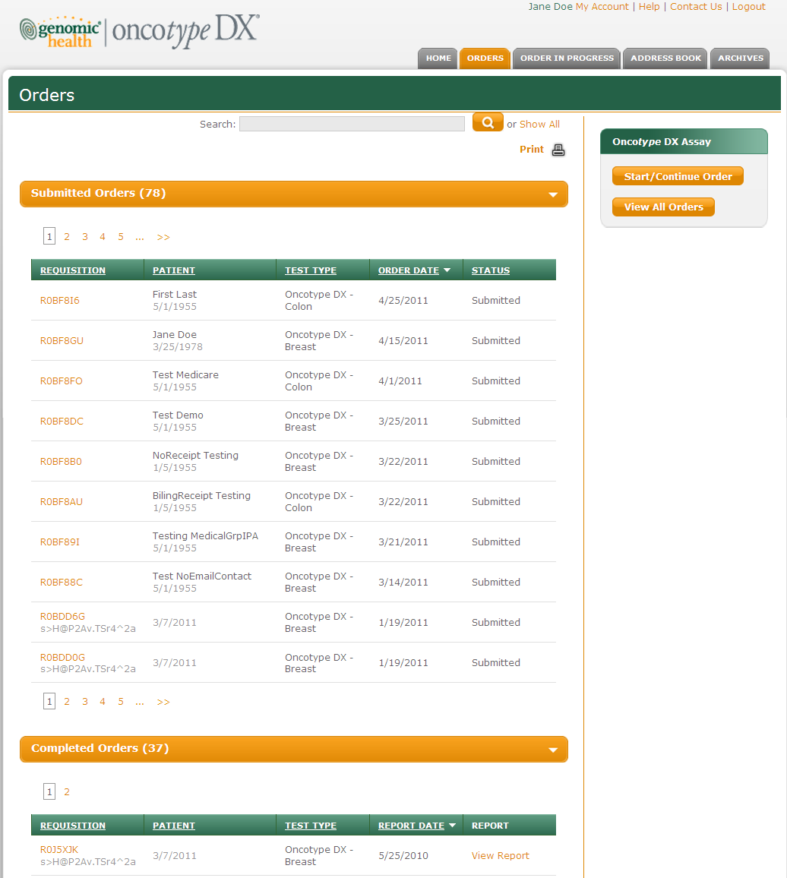

The test type column should read as follows:

Breast:

* Invasive Breast
* DCIS Breast

Colon

1. MMR

2. Oncotype DX Colon

3. MMR/ODX

## Submitted Orders

Submitted Orders displays orders that have not yet produced a report and are still being processed by the lab. The following information is displayed:



## Completed Orders

Completed Orders displays orders that have produced a report which is available for download. The following information is displayed:



# Order DEtails

|  |  |  |
| --- | --- | --- |
| **CONTENT**  **OWNERS** | **Department** | **Responsible Person** |
| Commercial Operations | Stephen Adams |
| Customer Service | Leslie Marquez |
| **PURPOSE** | The Order Details page lists information about an order. As the order is processed in SARP, the information on the Order Details page is updated accordingly. Additional information will be available for orders placed online. | |

| **Orders Page - Content** | |
| --- | --- |
| **Field or Object** | **Label/Content** |
| Browser window title | Order Details |
| Banner title | Order Details |

The Order Details page will look like this:

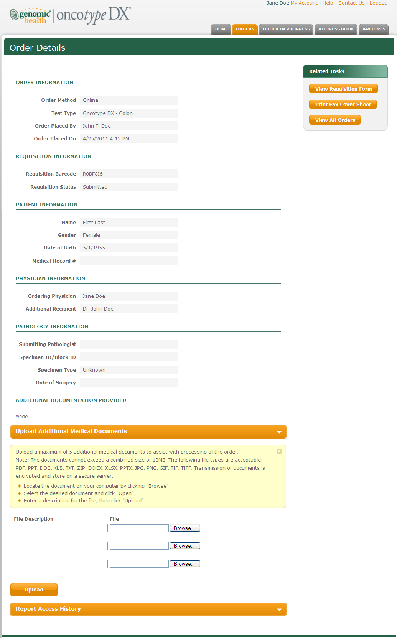

## Order Details

The Order Details page contains the following information.

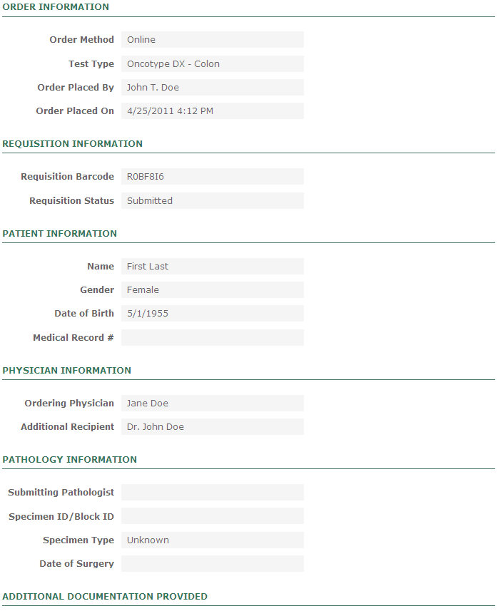

# Online Ordering

|  |  |  |
| --- | --- | --- |
| **CONTENT**  **OWNERS** | **Department** | **Responsible Person** |
| Commercial Operations | Stephen Adams |
| Customer Service | Leslie Marquez |
| **PURPOSE** | The Online Ordering feature allows authorized users to place Oncotype DX orders online. | |

## Start/Continue Order Page

| **Start/Continue Order - Content** | |
| --- | --- |
| **Field or Object** | **Label/Content** |
| Browser window title | Start/Continue Order |
| Banner title | Start/Continue Order |

The **Start/Continue Order** page can be accessed by the user from the Home or Orders tab and looks like this:

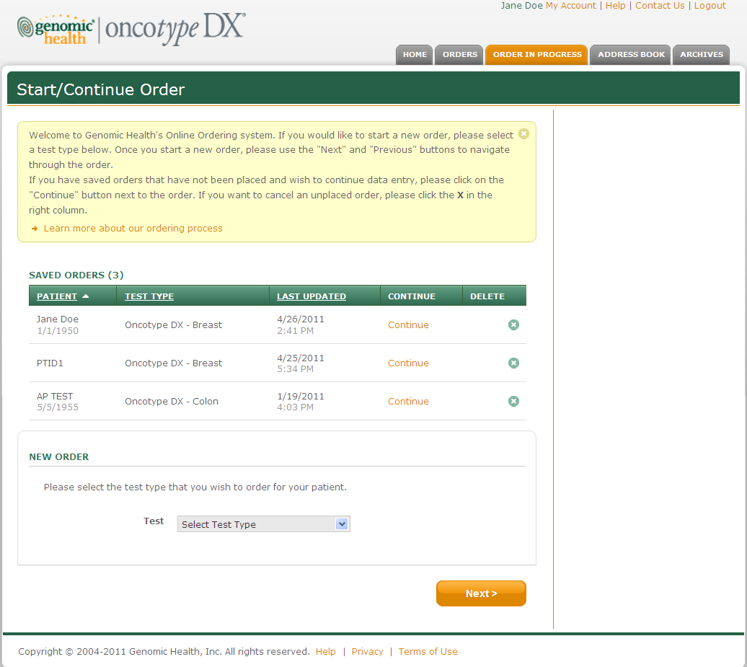

The following fixed text will appear in a yellow box that can be closed by the user, if desired:

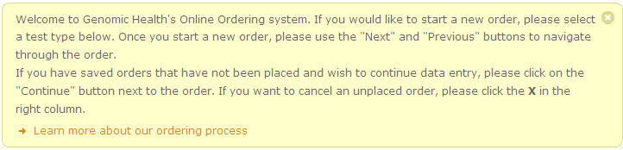

Welcome to Genomic Health’s Online Ordering system. If you would like to start a new order, please select a test type below. Once you start a new order, please use the “Next” and “Previous” buttons to navigate through the order.

If you have saved orders that have not been placed and wish to continue data entry, please click on the “Continue” button next to the order. If you want to cancel an unplaced order, please click the X in the right column.

If the user chooses to Learn more about the ordering process the following information will appear.

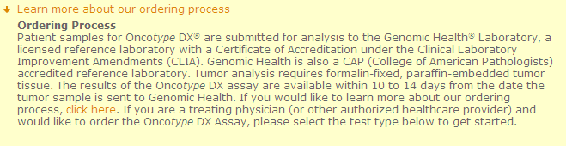

**Ordering Process**

Patient samples for the Onco*type* DX® assay are submitted for analysis to Genomic Health, a licensed clinical laboratory with a Certification of Accredidation under the Clinical Laboratory Improvements Amendments (CLIA). Genomic Health is also a CAP (College of American Pathologists) accredited clinical laboratory. Tumor analysis requires one fixed paraffin-embedded tumor block (neutral buffered formalin is the preferred fixative).The results of the Onco*type* DX assay are available within 10-14 days from the date the tumor sample is received by Genomic Health. If you would like to learn more about our ordering process, click here. If you are a treating physician (or other authorized healthcare provider) and would like to order the Onco*type* DX Assay, please select the test type below to get started.

### Order in Progress

If the user has saved orders they have not yet submitted, they can access the order by selecting the Continue option within the following columns:

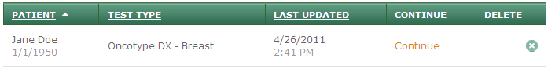

## New Order Test Type

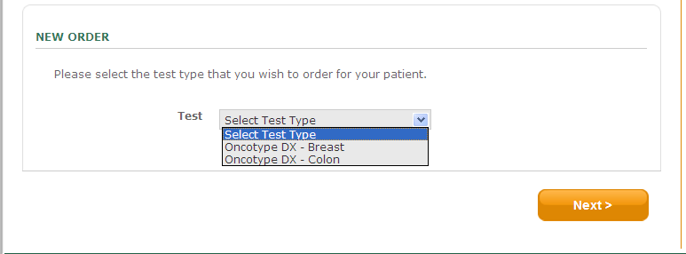

Please select the test type that you wish to order for your patient.

### Oncotype DX - Breast

If the customer selects the breast assay, the following test type options will appear:

* + - DCIS Score™ for Ductal Carcinoma In Situ Patient (no invasive cancer present)
      * If the customer selects this option, the following statement will appear:
        + All Onco*type* DX Breast Cancer Assay reports for DCIS patients will include the breast cancer DCIS score, as well as ER and PR scores.
    - Recurrence Score for Invasive Breast Cancer Patient
      * If the customer selects this option the following statement will appear.
        + All Onco*type* DX Breast Cancer Assay reports for invasive breast cancer patients will include the breast cancer Recurrence Score, as well as ER, PR, and HER2 scores.



### Oncotype DX - Colon

#### If the customer selects the colon assay, the following test type options will appear:

#### Sequential Assays: MMR then Onco*typ*e DX Colon Cancer if MMR is Proficient

* + - * If the customer selects this option the following statement will appear:



* + - Oncotype DX Colon Cancer Assay
      * If the customer selects this option the following statement will appear:



* + - MMR Assay for Recurrence Risk Assessment

## Navigation

Navigation controls for entering order information look like this:



## Patient Tab - Breast

| **Patient - Content** | |
| --- | --- |
| **Field or Object** | **Label/Content** |
| Browser window title | Patient |
| Banner title – Breast – DCIS test option | Oncotype DX – Breast (Patient with DCIS): Patient Name |
| Banner title – Breast – IBC test option | Oncotype DX – Breast (Patient with Invasive BC): Patient Name |

### Clinical Information - Breast

The **Clinical Information** section of the **Patient** page for Oncotype DX Breast orders:

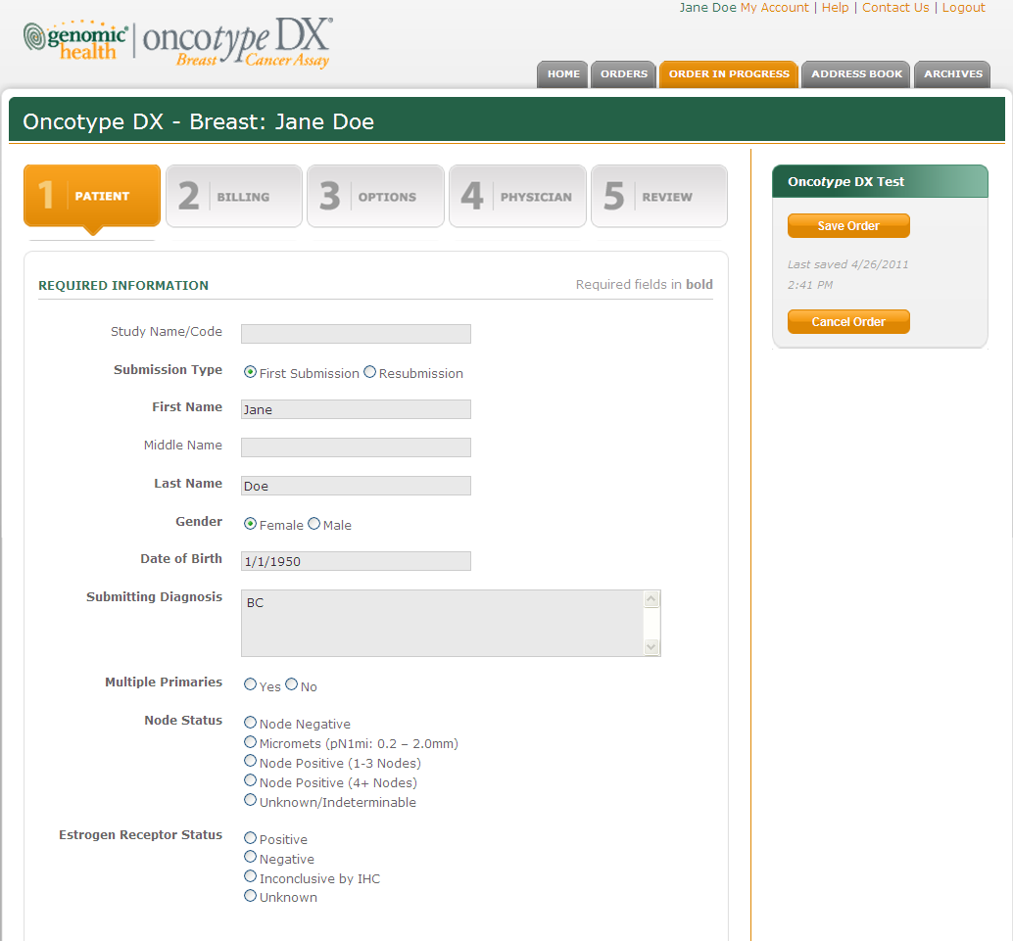

Change Required Information to Clinical Information

#### Node Status

The Patient page includes a field to capture the Node Status of the specimen being submitted. The five options are:



Change the last option to read Unknown, delete the word Indeterminable

Node status is a required data field for IBC orders, but is not visible for DCIS orders.

#### ER Status

The Patient page includes a field to capture the Estrogen Receptor Status of the specimen being submitted. The four options are:

* Positive
* Negative
* Inconclusive by IHC: If the customer selects “Inconclusive by IHC,” the following statement will display in the right margin of the online ordering screen:
  + “This selection indicates that the patient’s ER status is inconclusive based on the interpretation of immunohistochemical studies. This selection may impact patient results. If found to be ER Negative by RT-PCR, the physician will receive a failure report.”

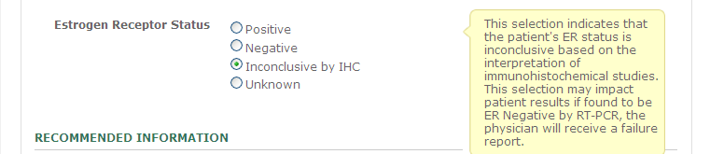

* Unknown: If the customer selects “Unknown” the following statement will display in the right margin of the online ordering screen:
  + A representative will contact you.

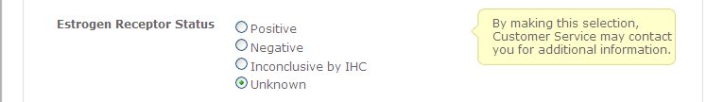

ER Status is a required data field for IBC orders, but is not visible for DCIS orders.

## Patient Tab – Colon

| **Patient - Content** | |
| --- | --- |
| **Field or Object** | **Label/Content** |
| Browser window title | Patient |
| Banner title – Colon - MMR | Oncotype DX – Colon (MMR for Recurrence Risk Assessment): Patient Name |
| Banner title – Colon – Cancer Assay | Oncotype DX – Colon: Patient Name |
| Banner title – Colon – Sequential Assays | Oncotype DX – Colon (Sequential Assays): Patient Name |

### Clinical Information – Colon

The Clinical Information section of the Patient page for Oncotype DX Colon orders:

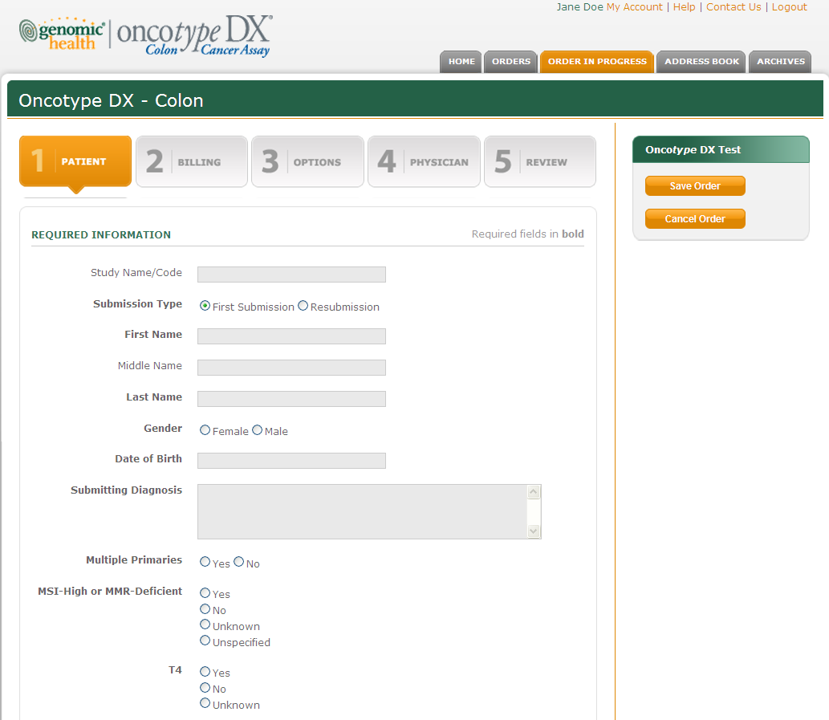

Submission Type - If a customer selects Resubmission, the text box to enter the Associated Requisition appears.

Change Required Information to Clinical Information.

Remove the Unspecified option from MMR-Deficient,

### Clinical Information

#### Remove MSI-High so the statement reads “MMR-Deficient”. Not visible for MMR orders.

#### The clinical information required is dependant on the customers test type selection.

* Sequential Assays: MMR then Onco*typ*e DX Colon Cancer if MMR is Proficient
  + MMR is not visible.
  + T –stage is required
* Onco*type* DX Colon Cancer Assay
  + MMR is required
  + T-Stage is required
* MMR Assay for Recurrence Risk Assessment
  + MMR is not visible.
  + T-Stage is not visible.

## Multiple Primaries

If a customer selects “Multiple Primaries Yes” on the New Order Patient Page, he/she is prompted to enter the quantity of tumors being submitted.

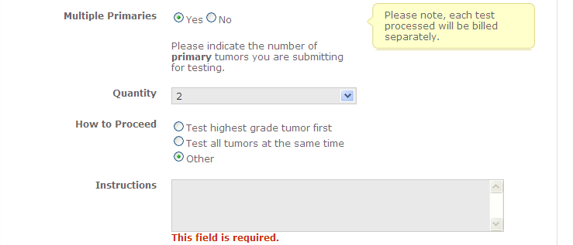

Please indicate the number of primary tumors you are submitting for testing.

* Yes
  + If “Yes” the following statement will display in the right margin of the online ordering screen.
    - “Please note, each test processed will be billed separately.”
* Quantity
  + The customer has the option to test two primaries. For consistency with the Requisition Form, remove the option to enter information for a 3rd and 4th specimen.
* How To Proceed:
  + Test highest grade tumor first
    - The ordering physician may be consulted before testing other tumors.
  + Test all tumors at the same time.
  + Other
    - An “Instructions” box will appear for the customer to enter processing instructions.

## Recommended Information – Breast & Colon

The **Recommended Information** section of the **Patient** page will look like this for all orders:

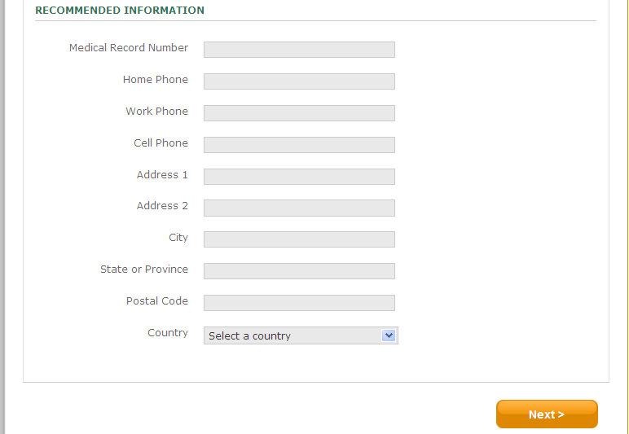

The following fixed text will appear in a yellow box:

“Patient contact information is required for private, Medicare, or Medicaid insurance.”

Change Home Phone to “Primary Phone”, change Work Phone to “Alternate Phone”, and remove the Cell Phone field.

Change Address 1 to “Address”, and remove the Address 2 field. (pending feedback from Customer Service)

## Online Ordering – Billing Tab

| **Billing Tab - Content** | |
| --- | --- |
| **Field or Object** | **Label/Content** |
| Browser window title | Billing |
| Banner title - Colon | Oncotype DX – Colon (Test Type): Patient Name (if available) |
| Banner title – Breast | Oncotype DX – Breast (Test Type): Patient Name (if available) |

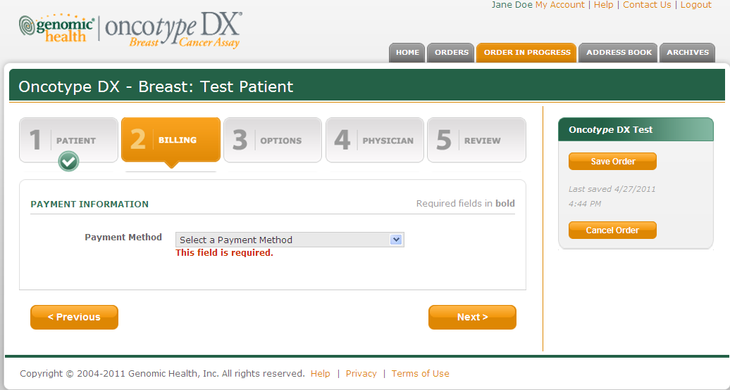

The **Payment Method** field is a dropdown list with the following options:

1. Private Insurance (US Carriers Only) / Medicaid
2. Medicare
3. Patient Self-Pay – Credit Card
4. Bill Account
5. Uninsured Patient
6. CARE Survey (Colon Only)

### ICD-9 Codes

Private Insurance and Medicare submissions require an ICD-9 code. Below is a list of all ICD-9 codes the customer can choose:

#### Breast - DCIS ICD-9 Codes

|  |  |
| --- | --- |
| 233.0 | DCIS - Unspecified type of carcinoma in situ of unspecified breast |
| 174.0 | Malignant neoplasm of nipple and areola, unspecified female breast |
| 238.3 | Neoplasm of uncertain behavior of unspecified breast |
| Other | Specify below |

* 233.0 - DCIS – Unspecified type of carcinoma in situ of unspecified breast
  + Popup: Not validated for lobular carcinoma in situ – LCIS.
* 238.3 Neoplasm of uncertain behavior of unspecified breast
  + Popup: “A representative will contact you.”

#### Breast – Invasive Breast Cancer ICD-9 Codes

|  |  |
| --- | --- |
| 174.0 | Malignant neoplasm of nipple and areola, unspecified female breast |
| 174.1 | Malignant neoplasm of central portion of unspecified female breast |
| 174.2 | Malignant neoplasm of upper-inner quadrant of unspecified female breast |
| 174.3 | Malignant neoplasm of lower-inner quadrant of unspecified female breast |
| 174.4 | Malignant neoplasm of upper-outer quadrant of unspecified female breast |
| 174.5 | Malignant neoplasm of lower-outer quadrant of unspecified female breast |
| 174.6 | Malignant neoplasm of axillary tail of unspecified female breast |
| 174.8 | Malignant neoplasm of overlapping sites of unspecified female breast |
| 174.9 | Malignant neoplasm of unspecified site of unspecified female breast |
| 175.0 | Malignant neoplasm of nipple and areola, unspecified male breast |
| 175.9 | Malignant neoplasm of unspecified site of unspecified male breast |
| Other | Specify below |

#### Colon – All Colon Assays

|  |  |
| --- | --- |
| 153.0 | Malignant neoplasm of hepatic flexure |
| 153.1 | Malignant neoplasm of transverse colon |
| 153.2 | Malignant neoplasm of descending colon |
| 153.3 | Malignant neoplasm of sigmoid colon |
| 153.4 | Malignant neoplasm of cecum |
| 153.5 | Malignant neoplasm of appendix |
| 153.6 | Malignant neoplasm of ascending colon |
| 153.7 | Malignant neoplasm of splenic flexure |
| 153.8 | Malignant neoplasm of overlapping sites of colon |
| 153.9 | Malignant neoplasm of colon, unspecified |
| Other | Specify below |

### 153.5 – Malignant neoplasm of appendix

Popup: “A representative will contact you.”

### Private Insurance (US Carriers Only)/ Medicaid

The **Billing** page for Private Insurance and Medicaid insurances will look like this:

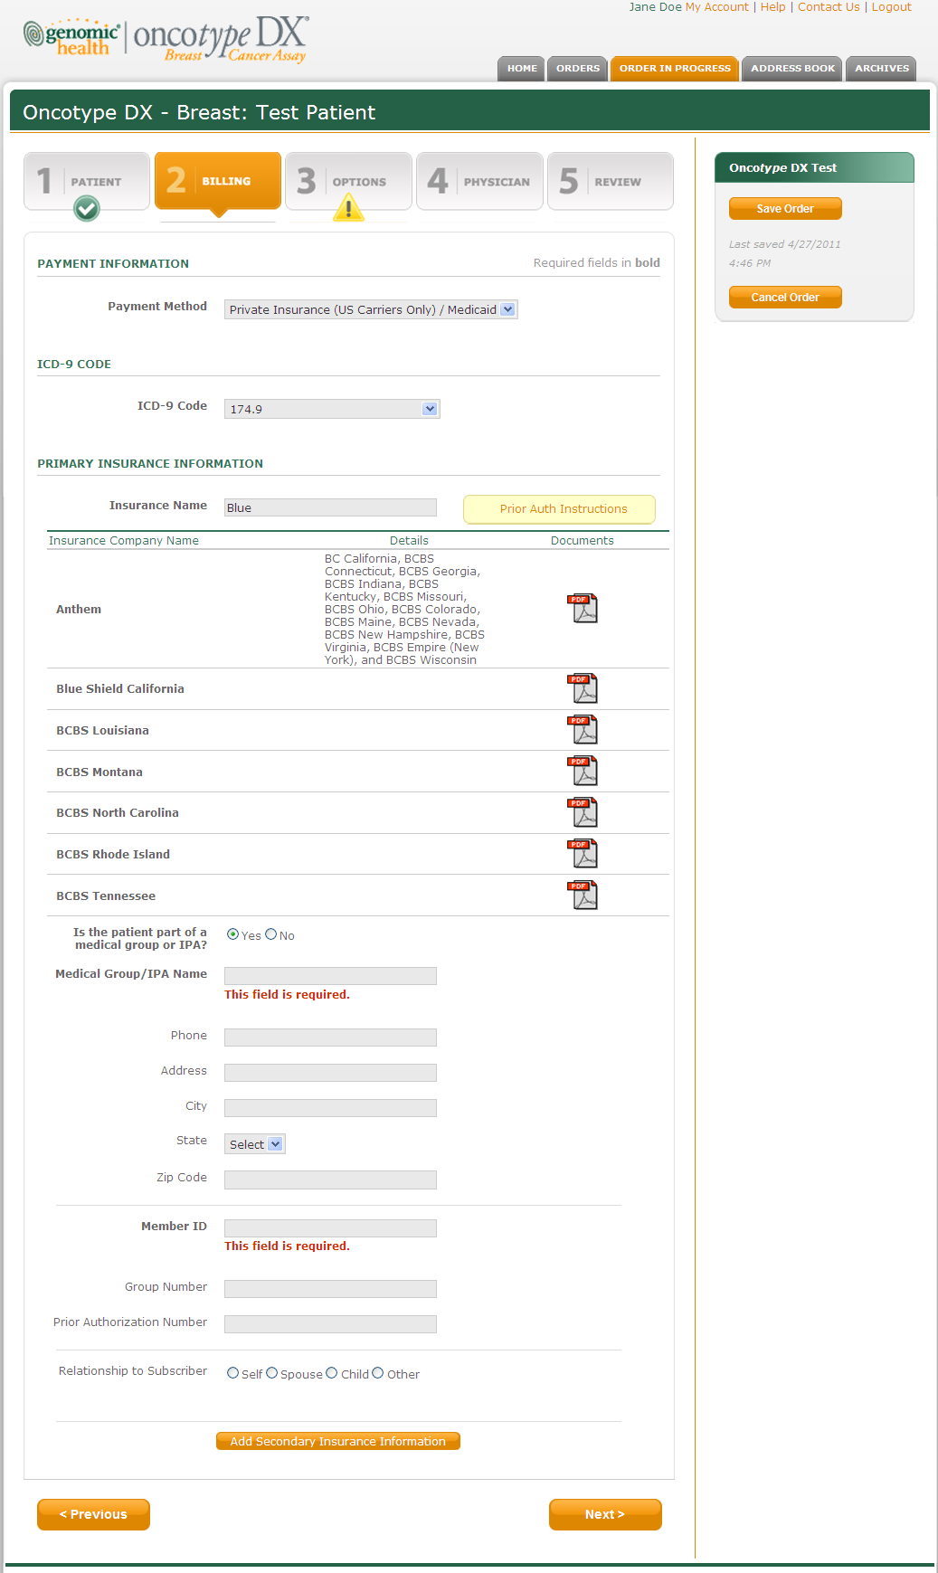

When typing the Insurance Name the portal will check if a Prior Auth form is available. All Prior Auth forms are stored in the Health Insurance Coverage section of the Help menu.

If a customer selects Payment Method of Private Insurance, a new field under Primary Insurance Information asks “Is the patient part of a Medical Group or IPA?” If yes, a text box appears to enter the “Medical Group/IPA Name.”

### Medicare

**Background**: Medicare fields are almost identical to the Private/Medicaid fields. The only difference is that there are two additional required fields for Medicare.

The Medicare-specific section of the Billing page will look like this:

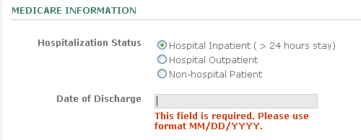

### Patient Self-Pay – Credit Card

The Billing page for **Patient Self-Pay – Credit Card** will look like this:

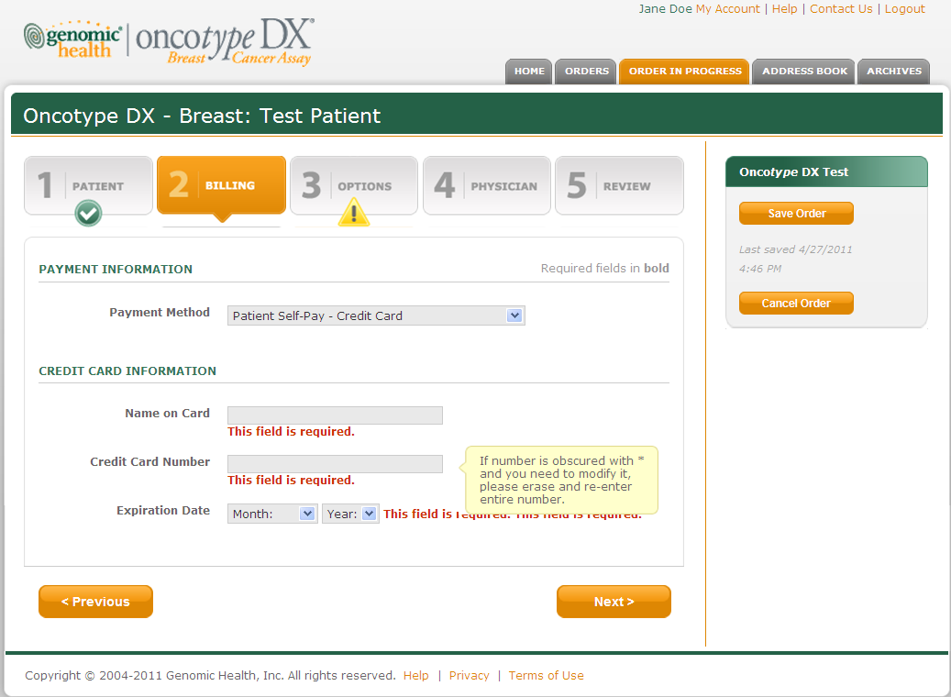

When entering the Credit Card Number, a text box appears stating the following:

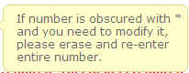

### Bill Account

The **Billing** page for **Bill Account** will look like this:

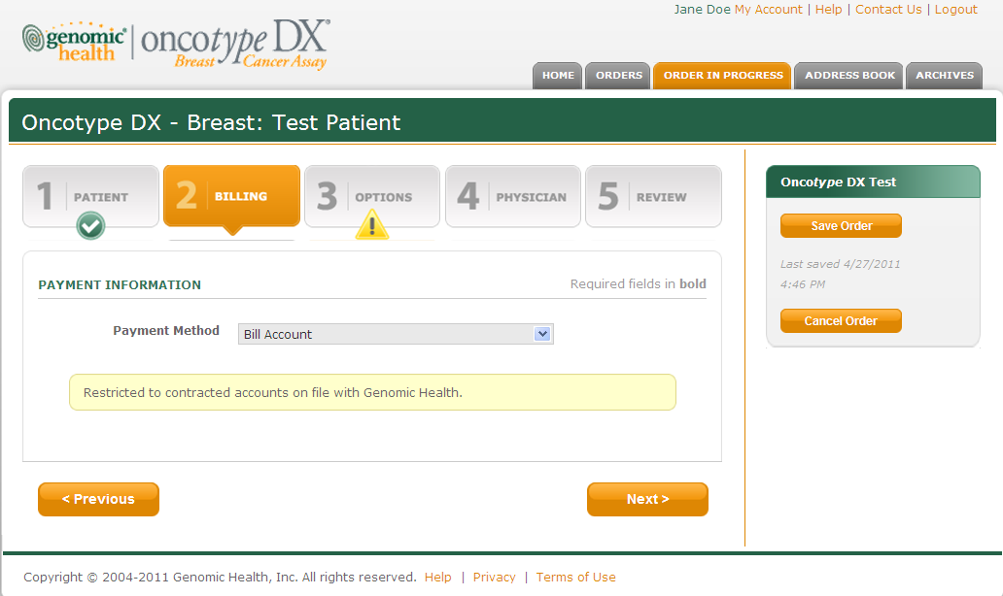

When Bill Account is selected, the following text box appears:



### Uninsured Patient

The **Billing** page for **Uninsured Patient** will look like this:

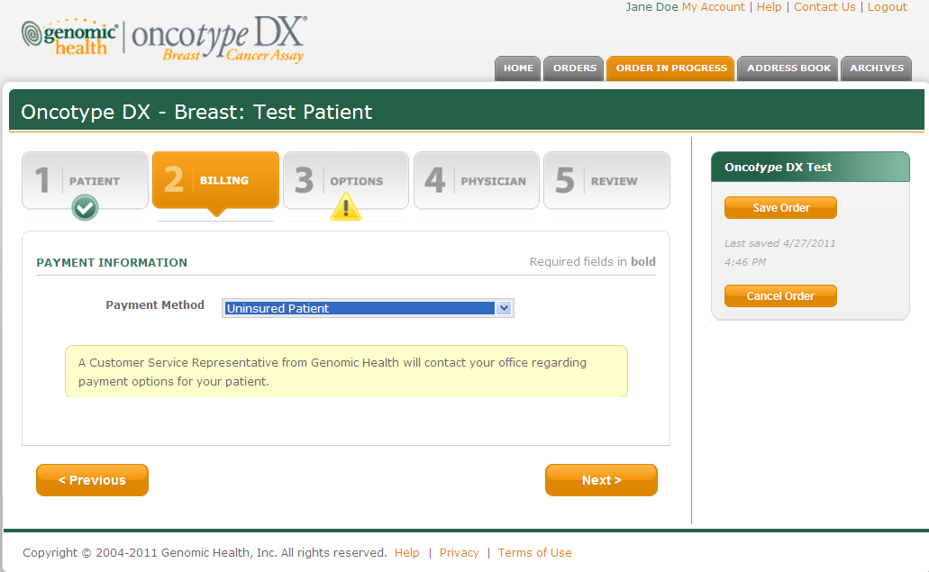

When uninsured patient is selected, the following text box appears:



A Customer Service Representative from Genomic Health will contact your office regarding payment options for your patient.

## Online Ordering – Options Tab

**Purpose**: The Options page contains information about Benefits Investigation and Specimen Retrieval.

| **Options Tab - Content** | |
| --- | --- |
| **Field or Object** | **Label/Content** |
| Browser window title | Options |
| Banner title - Colon | Oncotype DX – Colon (Test Type): Patient Name (if available) |
| Banner title – Breast | Oncotype DX – Breast (Test Type): Patient Name (if available) |
| **Options Tab - Content** | |
| **Field or Object** | **Label/Content** |
| Browser window title | NewOrderOptions |
| Banner title | Options |

The **Options** page of Online Ordering will look like this:

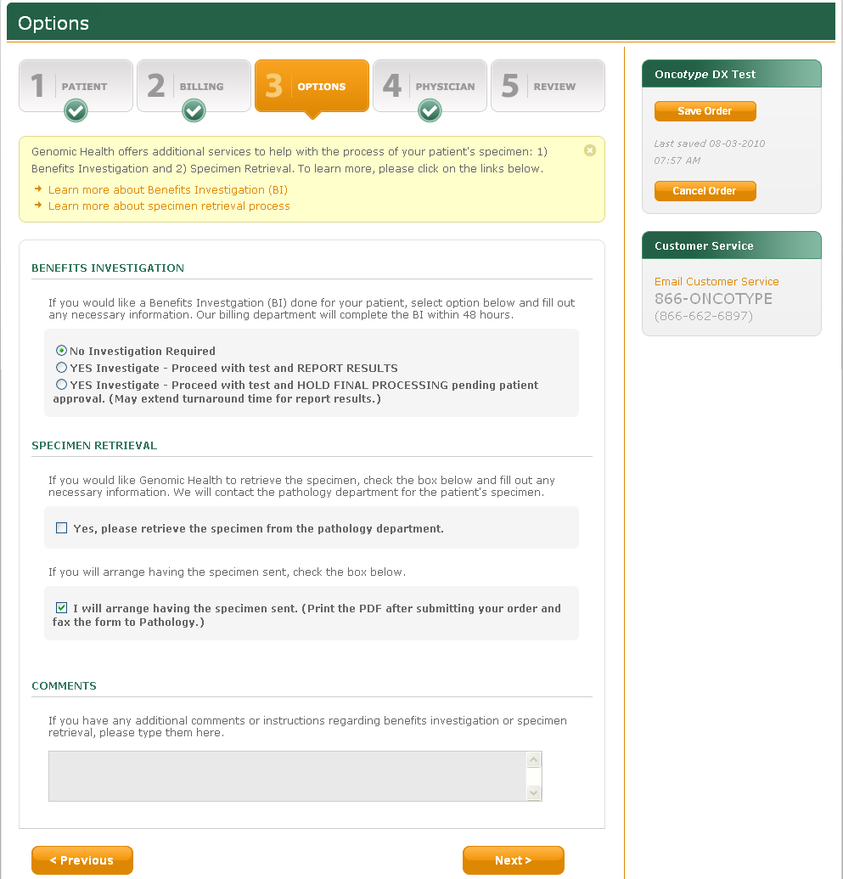

The following fixed text will appear in a yellow box that can be closed by the user, if desired:



Genomic Health offers additional services to help you and your patient facilitate the processing of your order: 1) Benefits Investigation and 2) Specimen Retrieval. To learn more, click on the links below.

If the user clicks to learn more about each of the options, the fo llowing information will appear:

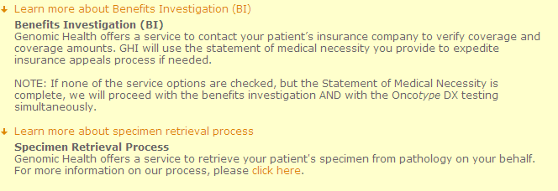

**Benefits Investigation (BI)**  
If requested at the time of order, Genomic Health will confirm coverage with the patient’s insurance for the Oncotype DX assay selected.  
 **Specimen Retrieval Process**  
If requested at the time of order, Genomic Health will contact pathology directly for retrieval of your patient’s specimen. For more information on our process, please click here.

If the user clicks “click here” they are taken to the How To Order Oncotype DX page.

### Benefits Investigation

If one of the “YES Investigate” options is selected, the **Statement of Medical Necessity** section will become visible; otherwise that field will be hidden:

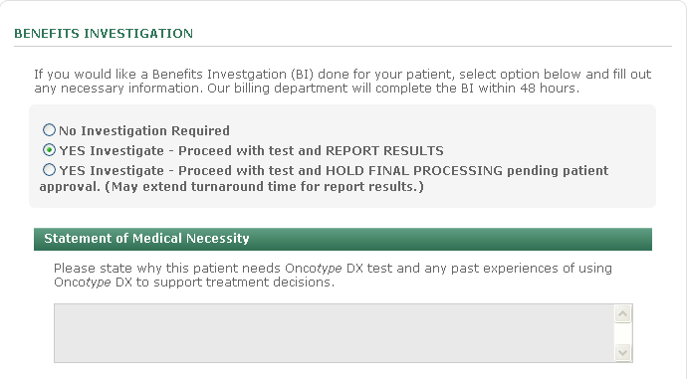

If you would like a Benefits Investigation (BI) for your patient, select the appropriate option below.

Colon only: The option for a BI is dependant on the customers test type selection:

* Remove the option for a BI if the test type selection is “MMR Assay for Recurrence Risk Assessment”.

### Specimen Retrieval

If the **Specimen Retrieval** Yes is selected, the **Pathology Department** dropdown menu becomes visible, otherwise it is hidden:

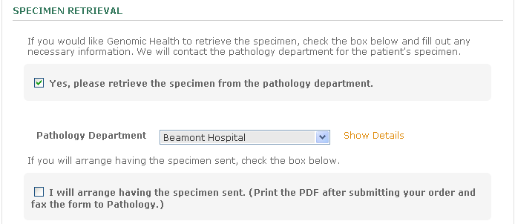

The user can click on **Show Details** to review the contact’s address and other contact information.

Similar to the International Portal, please Show the Details for the Pathology Department location on the screen. Also include a free form text box titled Contact, for customers to enter the name of a contact person at the location, without using the Address book.

## Online Ordering – Physician Tab

| **Options Tab - Content** | |
| --- | --- |
| **Field or Object** | **Label/Content** |
| Browser window title | Options |
| Banner title - Colon | Oncotype DX – Colon (Test Type): Patient Name (if available) |
| Banner title – Breast | Oncotype DX – Breast (Test Type): Patient Name (if available) |

The **Physician** page of Online Ordering will look like this:

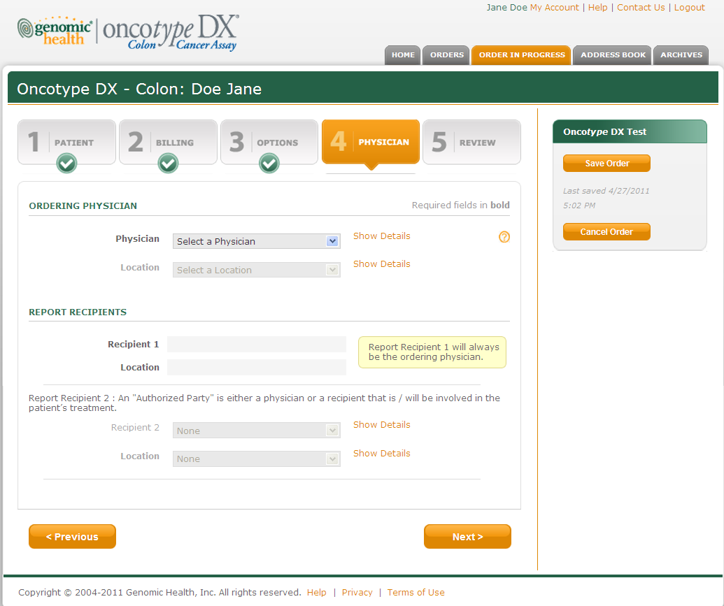

Under Report Recipients, a text box indicating the following will always be displayed.



Recipient 2 does not require an email address to enter the Contact and submit the order.

The user can click on **Show Details** to review the contact’s address and other contact information.

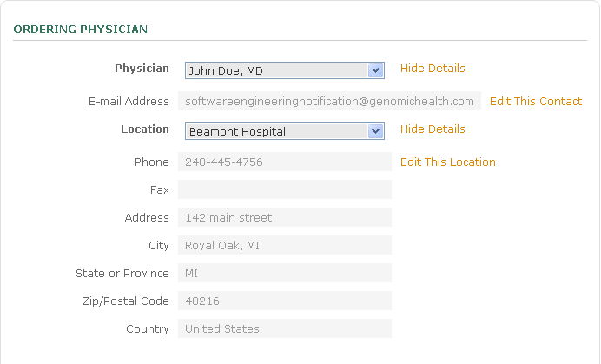

## Online Ordering – Review Order Page

**Purpose**: The Review Order page gives the user the opportunity to review the information in the order and to correct any errors detected by the software.

| **Review Tab – Content** | |
| --- | --- |
| **Field or Object** | **Label/Content** |
| Browser window title | Review Order |
| Banner title – Colon | Oncotype DX – Colon (Test Type): Patient Name (if available) |
| Banner title – Breast | Oncotype DX – Breast (Test Type): Patient Name (if available) |

The **Review Order** page of Online Ordering will look like this:

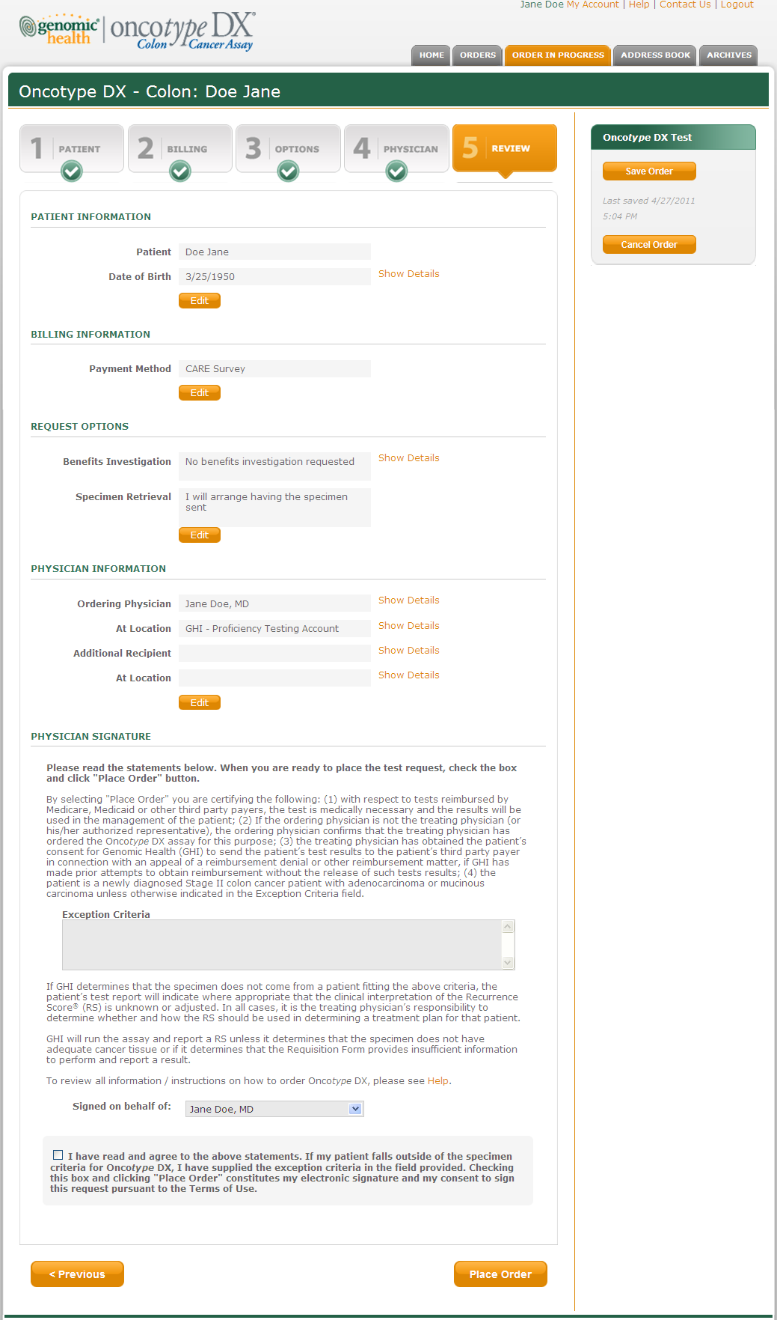

### Physician Signature

Content within the Physician Signature can be found later in this document, the above screen shot is only meant to display the users view at this time in the process.

### Online Ordering – Error Checking

When the user finishes entering order information and navigates to the **Review** page, the software checks to make sure that all required information has been entered. An error message will display if required information is missing.

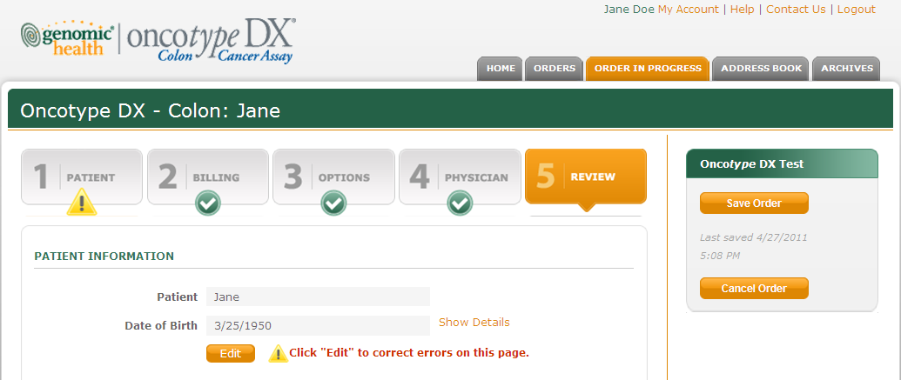

A green checkmark will be displayed on the Online Ordering tabs that have been completed successfully.



## Online Ordering – Order Confirmation

**Purpose**: The Order Confirmation Page will show all the details of the order immediately after it is submitted. This page will not be available after the user navigates away from it. All the information, will be available in the Order Detail Page.

The Order Confirmation Statement will be displayed at the top of the Home page and will look like this:

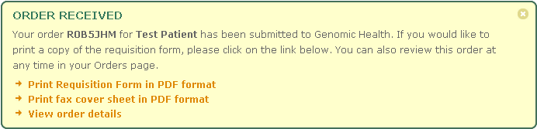

## Online Ordering – Email Notifications

**Email to Customer Service**

An Email notification will be sent to Customer Service whenever a new order is submitted. The email will contain a link to the order information in Portal Manager.

***Sample email to Customer Service:***

From: Portal Notifications [<mailto:portal@genomichealth.com>]

Sent: Friday, October 17, 2008 10:15 AM

To: customerservice@genomichealth.com

Subject: New Online Order RXXXXXX Placed

New online order has been place with requisition barcode RXXXXXX.

To view the order, please click on [URL link]

**Email to the Customer**

An Email notification will be sent to the user and his/her sponsor as confirmation of receipt of the order.

Dear <FullName>:

Thank you for requesting an Oncotype DX®Assay with Genomic Health Inc. The results should be available within 7-10 days from the date the tumor sample is received at Genomic Health. You will receive an email when the report is posted to your online account. To check on the status or place another order, please visit <https://online.genomichealth.com>.

Please contact Customer Service with any additional questions.

**Corporate Headquarters**

customerservice@genomichealth.com

866-ONCOTYPE

(866-662-6897)

**Outside of U.S.**

international@genomichealth.com

+1 650 569 2080

----------------------------------------------------  
  
Requisition: <RequisitionBarcode>

Order Date: <OrderDate>

## Online Ordering – FAX Cover Sheet

The Fax Cover Sheet can be viewed or printed.

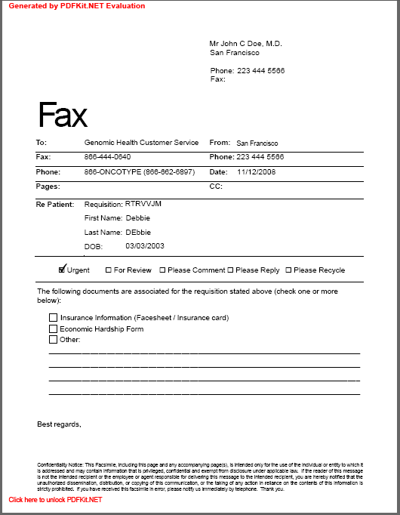

# Address Book & My Account

|  |  |  |
| --- | --- | --- |
| **CONTENT**  **OWNERS** | **Department** | **Responsible Person** |
| Customer Service | Stephen Adams |
| IT/SOFTWARE ENGINEERING | Sonya Natanzon |
| **PURPOSE** | The Address Book allows users to manage their individual contacts and locations that will be used in ordering Oncotype DX tests. | |

## Address Book

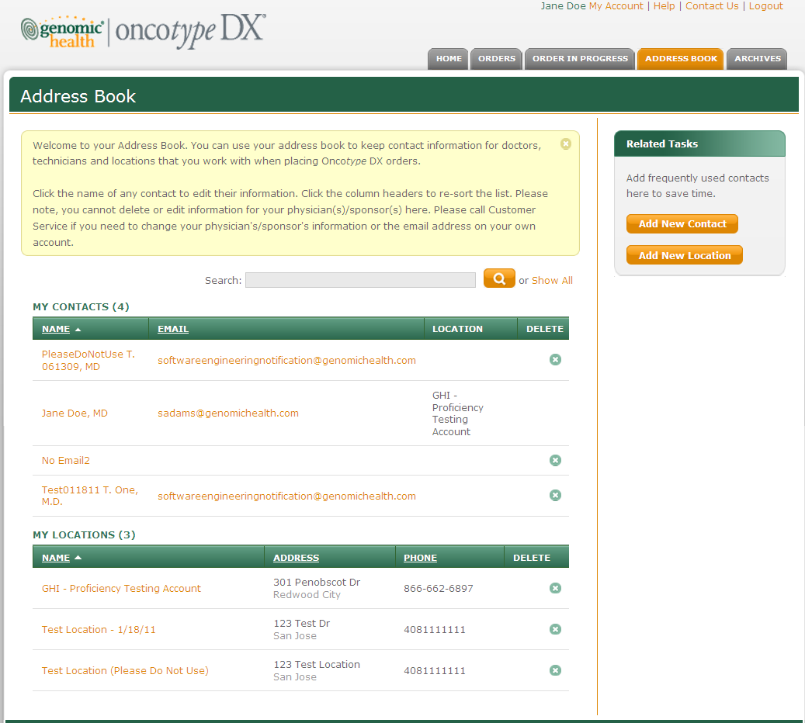

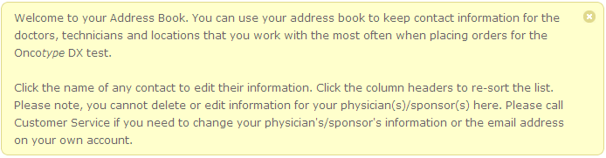

Welcome to your Address Book. You can use your Address Book to keep contact information for doctors, technicians, and locations that you work with when placing Onco*type* DX orders.

Click the name of any Contact to edit their information. Click the column headers to re-sort the list. Please note, you cannot delete or edit information for your physician(s)/sponsor(s) here. Please contact Customer Service if you need to change your physician’s/sponsor’s information or the email address on your own account.

## Address Book – Add/Edit Contact

The Add/Edit Contact page will look like this:

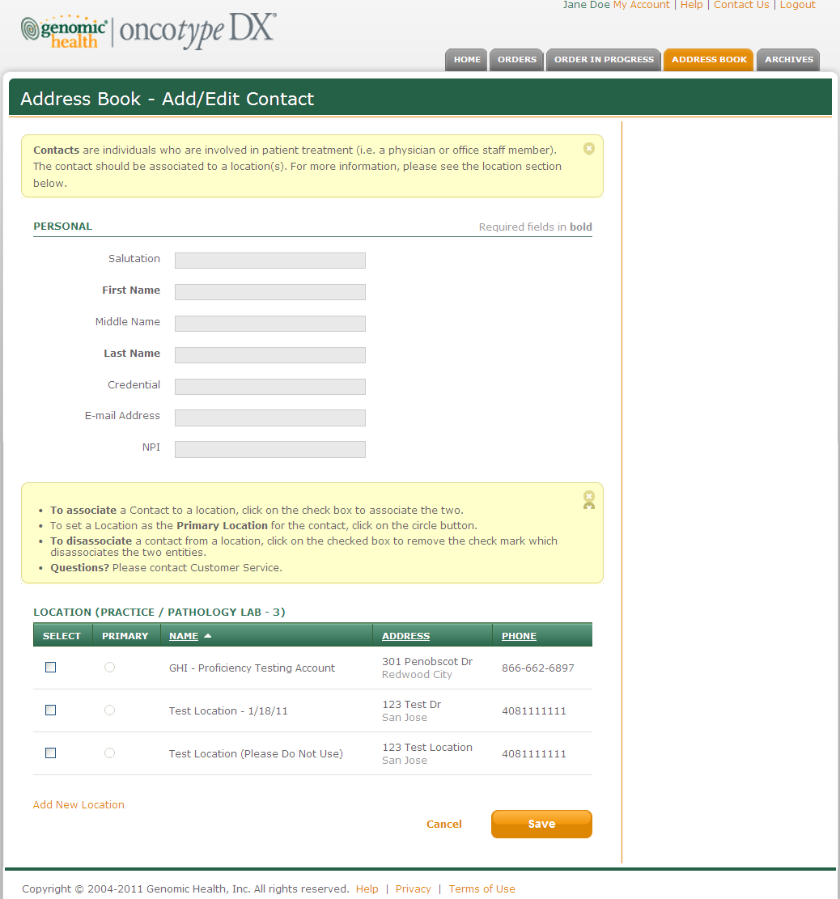

Change E-mail Address to Email Address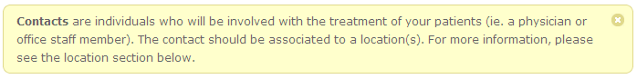**Contacts** are individuals who are involved in patient treatment (i.e. a physician or office staff member). The contact should be associated to a location(s). For more information, please see the location section below.

**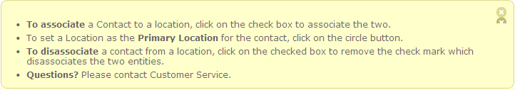**

* **To associate** a Contact to a location, click on the check box to associate the two.
* To set a Location as the **Primary Location** for the Contact, click on the circle button.
* **To disassociate** a contact from a location, click on the checked box to remove the check mark.
* **Questions?** Please contact Customer Service.

## Address Book – Add/Edit Location

The Add/Edit Location page will look like this:

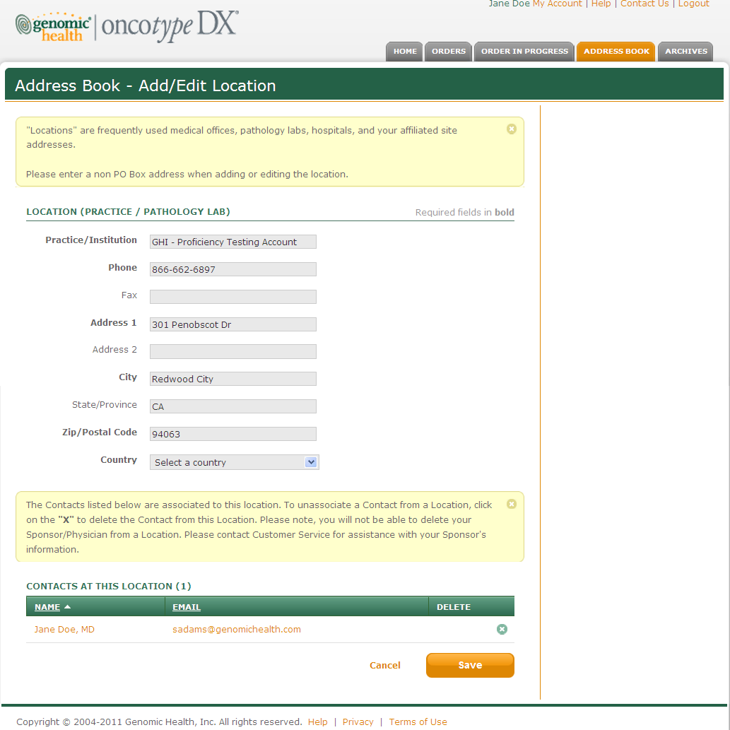

Country has been moved after zip-postal code. Location has been changed to Practice/Institution.

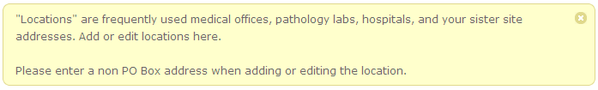

“Locations” are frequently used medical offices, pathology labs, hospitals, and your affiliated site addresses.  
Please enter a non PO Box address when adding or editing the location.

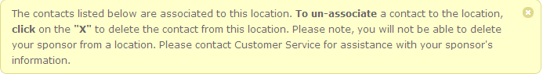

The Contacts listed below are associated to this Location. To disassociate a Contact from a Location, click on the “X” to delete the Contact from the Location. Please note, you are not able to delete your Sponsor/Physician from a Location. Please contact Customer Service for assistance with your Sponsor’s information.

# My Account

The My Account page allows the user to change his/her password and security questions and view My Locations, My Physicians, and My Delegates. See the **Login & Security** section of this document for security questions.

## My Account

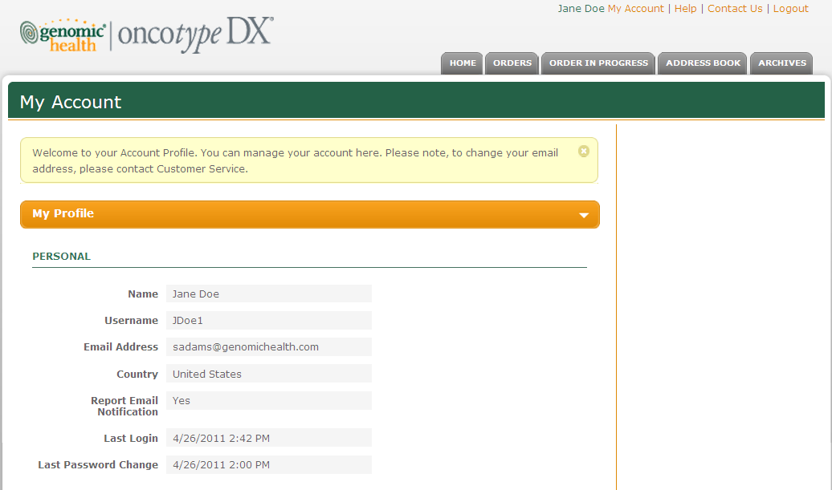



Welcome to your Account Profile. You can manage your account here. To change your email address, please contact Customer Service.

## Change Password

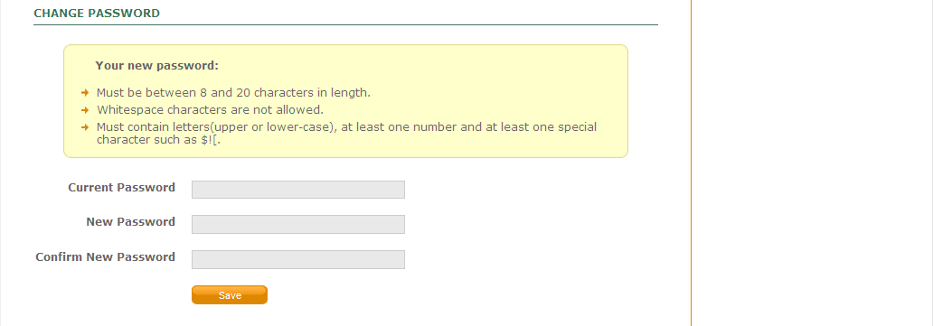

## Update Security Questions

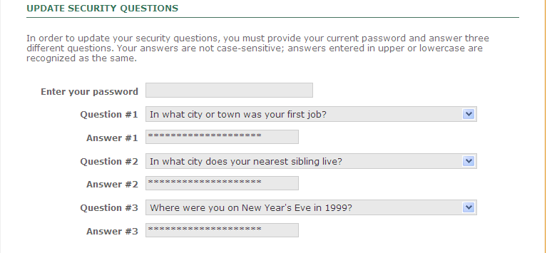

## My Locations & Delegate Management

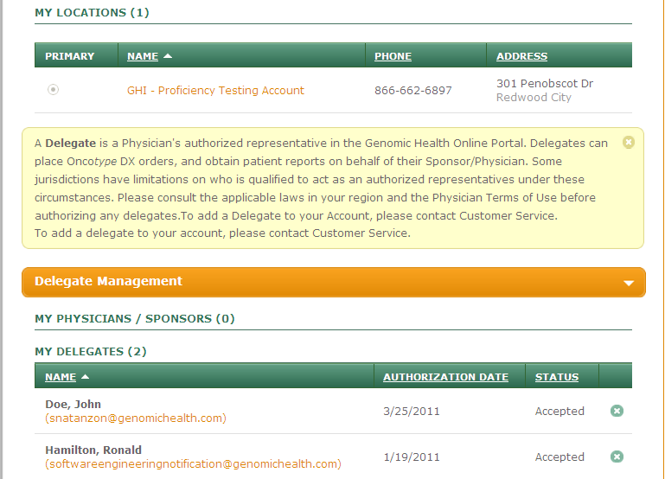

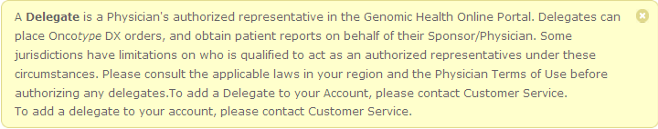

A **Delegate** is a Physician’s authorized representative in the Genomic Health Online Portal. Delegates can place Onco*type* DX orders, and obtain patient reports on behalf of their Sponsor/Physician. Some jurisdictions have limitations on who is qualified to act as an authorized representatives under these circumstances. Please consult the applicable laws in your region and the Physician Terms of Use before authorizing any delegates. To add a Delegate to your Account, please contact Customer Service.

The user can quickly email any of their delegates by clicking on their email address.

# Archives

|  |  |  |
| --- | --- | --- |
| **CONTENT**  **OWNERS** | **Department** | **Responsible Person** |
| Commercial Operations | Stephen Adams |
| GHI Chief Security Officer | Ken Stineman |
| **PURPOSE** | The Archives page allows customers to upload documents to GHI. Because uploaded documents could potentially contain viruses, the GHI Chief Security Officer is an owner of this page. | |

The **Archives** page looks like this:

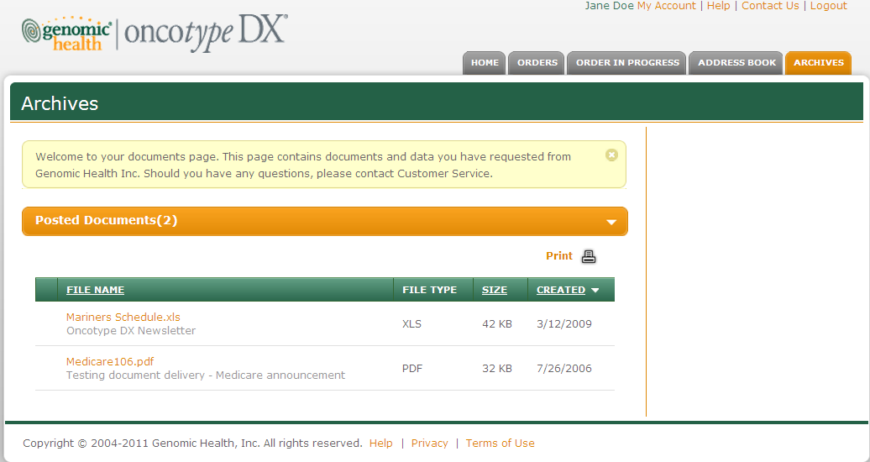



Welcome to your documents page. This page contains documents and data you have requested from Genomic Health Inc. Should you have any questions, please contact Customer Service.

# Contact Us Page

|  |  |  |
| --- | --- | --- |
| **CONTENT**  **OWNERS** | **Department** | **Responsible Person** |
| Commercial Operations | Stephen Adams |
| Customer Service | Leslie Marquez |
| **PURPOSE** | The Email Customer Service page can be used by customers to Email information over a secure connection. | |

The **Contact Us** page looks like this:

The information displayed is based on the users selection from the Contact Information drop-down.

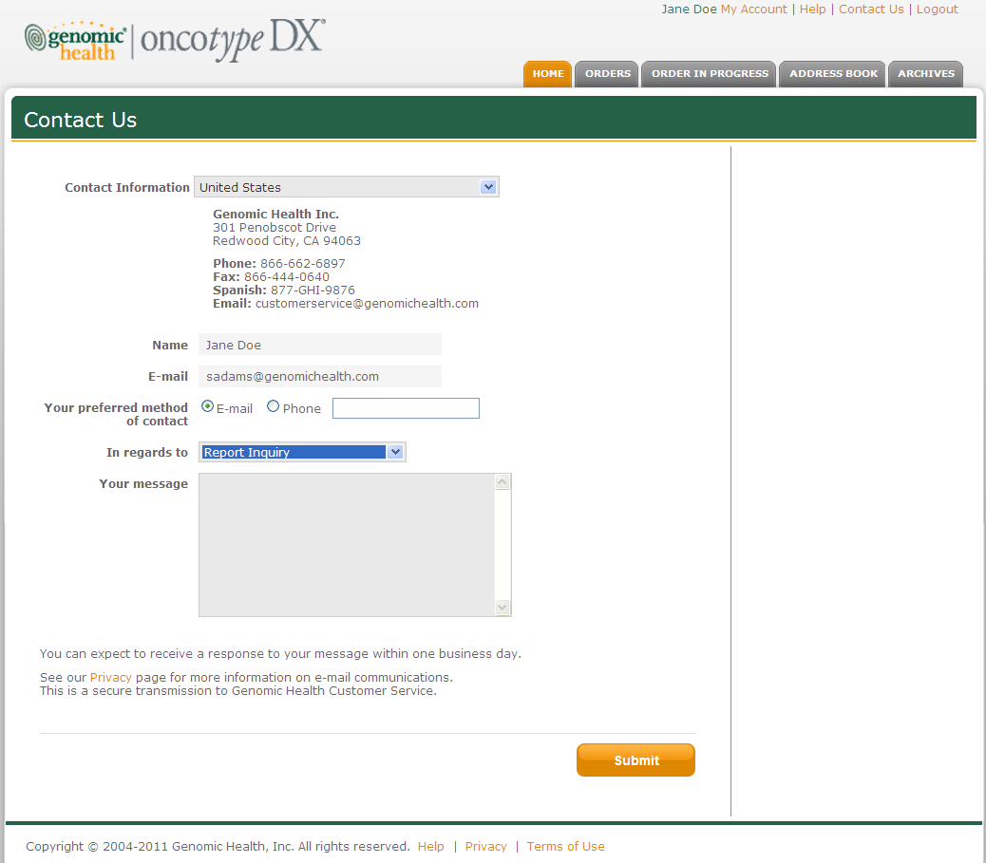

# Report Email Notification from Portal

Users will receive the below email from the Portal when a report is available for download.

Dear FullName:

An Oncotype DX report is available online for your patient:

Requisition: RequisitionBarcode

Received: ReportDate

To view this report, please login to Genomic Health Online at:

<https://online.genomichealth.com>

Please contact Customer Service with any questions.

**Domestic United States**

Email Customer Service

866-ONCOTYPE

(866-662-6897)

**International**

Email Customer Service

+1 650 569 2080

# Online Help Pages

|  |  |  |
| --- | --- | --- |
| **CONTENT**  **OWNERS** | **Department** | **Responsible Person** |
| Commerical Operations | Stephen Adams |
| Customer Service | Leslie Marquez |
| **PURPOSE** | Provide online help text for domestic users. | |

## Help Index

The information displayed on the Help pages depends on the users location. The below information corresponds to the domestic Help content. International Help content can be found in the International Portal BRS.

The Help page looks as follows:

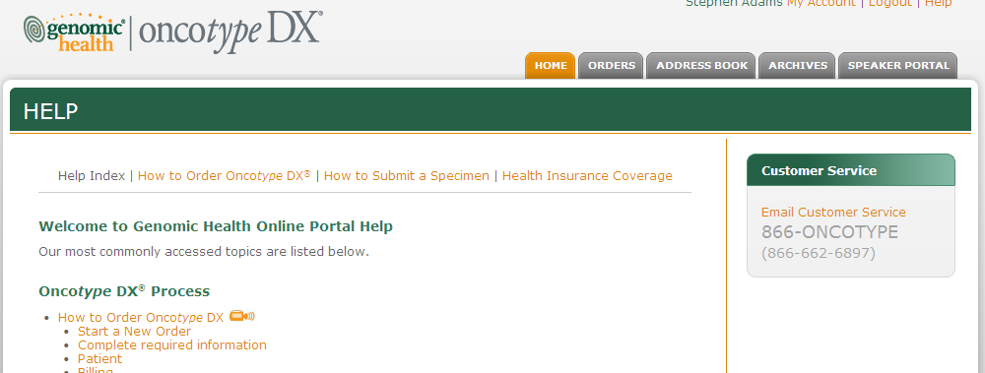

## Welcome to Genomic Health Online Portal Help

Our most commonly accessed topics are listed below.

### Oncotype DX® Process

* [How to Order Oncotype DX](http://onlinedev003.test/Help-HowToOrder.aspx#0)
* [How to Submit a Specimen for Oncotype DX](https://online.genomichealth.com/Help-HowToSubmitSpecimen.aspx)

### What does this status mean?

|  |  |
| --- | --- |
| * **Submitted:** | The order has been submitted via Genomic Health Online Ordering System. |
| * **Order Confirmed:** | Genomic Health Customer Service has received the order placed via Genomic Health Online Ordering System. |
| * **Processing Order:** | Genomic Health Customer Service is processing the order and will be in contact should they have any questions or need additional information. |
| * **Specimen In Lab:** | The specimen has been passed to the laboratory for processing.  Report results should be available in 7-10 days. |
| * **Complete:** | The Oncotype DX assay is complete. |
| * **Cancelled:** | The Onco*type* DX assay has been cancelled.  Should you have questions in regards to the cancellation, please contact Genomic Health Customer Service. |

### What do the icons mean?

**Main site tabs:**

|  |  |  |
| --- | --- | --- |
| https://online.genomichealth.com/images/help/x-circle.png | : | Delete or hide this information. |
| https://online.genomichealth.com/images/help/triangle-arrow-open.png | : | Section is maximized and showing. |
| https://online.genomichealth.com/images/help/triangle-arrow.png | : | Section is minimized.  Click on the arrow to maximize the section and view the information. |
| https://online.genomichealth.com/images/help/magnifying-glass.png | : | Click on the magnifying glass to start the search function. |
| https://online.genomichealth.com/images/help/dot.png | : | The document or information is unread. |
| https://online.genomichealth.com/images/help/sort.png | : | Click on the field to sort by that field; arrow up means that sort order is ascending; arrow down means that sort order is descending. |

**Online Ordering:**

|  |  |  |
| --- | --- | --- |
| https://online.genomichealth.com/images/help/complete.png | : | Information is complete for the section. |
| https://online.genomichealth.com/images/help/error.png | : | Information is incomplete for the section and must be completed before placing the order.  Click on the “Edit” button to go back the page to make the necessary changes. |

### How do I contact Genomic Health’s Customer Service?

Please go to [contact us](https://online.genomichealth.com/ContactUs.aspx) page.

### Self-Service Tools

* [View account information and change password](https://online.genomichealth.com/Account.aspx)
* [Manage Address Book](https://online.genomichealth.com/Contacts.aspx)

### Privacy Notice

Please read [Privacy Notice](http://www.genomichealth.com/privacy.aspx?Source=online).

## How to Order

### How do I order the Onco*type* DX assay?

The tumor analysis requires one fixed paraffin embedded tumor block (neutral buffered formalin is the preferred fixative). Results of the Oncotype DX cancer assay are available within 7 to 10 days from the date the tumor sample is received by Genomic Health.

* [How to Order Oncotype DX](https://online.genomichealth.com/Help-HowToOrder.aspx#0)  [Video: How to Order Oncotype DX](http://media.genomichealth.com/multimedia/Placing_An_Order_training/Placing_An_Order_training.htm)
* [Order Supplies/Questions](https://online.genomichealth.com/Help-HowToOrder.aspx#12)

### How to Order Oncotype DX

To order Oncotype DX for your patient, please follow the steps and additional information for online ordering.

### Helpful Hints

* Use the navigation buttons within the system to move between the screens. These navigation buttons include “Next”, “Previous” and numbered order steps at the top of each page.
* Do not use the “Back” or “Forward” buttons on your browser, as this will result in lost data.
* To save your order prior to completing, click the “Save” button to securely store your data.
* Saved orders will be available on the Start/Continue Order page.
* You may continue your saved orders at any time. You may also elect to cancel a saved order by clicking on the X located next to the Continue feature. Please note that this action cannot be undone.

**Order Steps**

* [Start/Continue Order](https://online.genomichealth.com/Help-HowToOrder.aspx#1)
* [Complete required information](https://online.genomichealth.com/Help-HowToOrder.aspx#2)
* [Patient](https://online.genomichealth.com/Help-HowToOrder.aspx#3)
* [Billing](https://online.genomichealth.com/Help-HowToOrder.aspx#4)
* [Options](https://online.genomichealth.com/Help-HowToOrder.aspx#5)
* [Physician](https://online.genomichealth.com/Help-HowToOrder.aspx#6)
* [Review Order / Attestation](https://online.genomichealth.com/Help-HowToOrder.aspx#7)
* [Changes to Submitted Orders](https://online.genomichealth.com/Help-HowToOrder.aspx#8)
* [Estimated Report Date (ERD)](https://online.genomichealth.com/Help-HowToOrder.aspx#9)
* [Results](https://online.genomichealth.com/Help-HowToOrder.aspx#10)   
  1. Click on **Start/Continue Order** button.
* To start a new order, select the Test Type and click Next.
* If you have saved orders, a list will be displayed.
  + To continue a saved order, select the order in the list and click on the Continue link.
  + To cancel a saved order, select the order from the list and click on the X button. This action cannot be undone.

**2. Complete** **all required** **information**.

* All required fields are in **bold**.
* You may navigate between order steps without completing all information. However, you will not be able to place the order until all required I is completed.

**3. PATIENT:**

* Patient Address is required when submitting an order for a patient with private / federal insurance.
* Multiple Primaries
  + If “Yes” is selected, additional specimen information must be provided. A high Recurrence Score® on one tumor likely results in a patient receiving chemotherapy. To avoid the additional cost to the patient for two Oncotype DX® tests, we recommend testing the more aggressive tumor first. After the Recurrence Score® is available we will contact your office for guidance on the testing of the second tumor. Genomic Health will hold the second tumor until the results of the first tumor are available. If this process does not meet your needs, please select “Other” and enter instructions in the Instructions box.
* Quantity: The patient’s number of primary tumors to be tested.
* Block ID Field: If you select “Test highest grade tumor first”, a request for the Specimen ID will appear. Missing Specimen ID may prompt a follow up from Genomic Health personnel.
* Billing for multiple primaries: please note that each test performed will be billed separately. Please call Customer Service for questions regarding reimbursement.
* DCIS Breast:
  + DCIS: A specimen submitted for the DCIS score must have no invasive cancer present.
* Invasive Breast
  + Nodal Status: The nodal status is required to determine the extent of the clinical experience information to be included in the report for your patient. If the nodal status is not provided, a report with clinical experience for both node negative and node positive specimens will be sent. Additionally, the node status is required for payor coverage determinations. If the nodal status is not specified,  Genomic Health will use the pathology report, if provided, to determine the nodal status for reimbursement purposes. Nodal Status is a requirement for all Medicare patients.
  + ER Status: A specimen submitted for Oncotype DX Breast Cancer Assay testing must be estrogen receptor positive (ER+) by either the IHC method used by a referring laboratory or the quantitative RT-PCR method used by GHI. If GHI determines that the submitted specimen is not ER+ by either method, a Recurrence Score will not be reported to the patient and the patient/payor will not be billed. You also have the option to indicate if the ER status is inconclusive based on the interpretation of immunohistochemical studies, or Unknown at the time of the order. All Oncotype DX Breast Cancer Assay result reports will include ER, PR and HER2 scores.
* Colon:
  + .
  + MMR-D: mismatch repair-deficient (specimens with a negative immunohistochemistry score for either MLH1 or MSH2).
  + T4: Tumor “T” stage “4”, the T stage reflects the level of invasiveness of the tumor through the wall of the colon.

[Top](https://online.genomichealth.com/Help-HowToOrder.aspx)

**4. BILLING:**

* Private Insurance (US Carriers Only) / Medicaid:
  + Please provide us with information taken directly from the patient’s insurance card.
  + Insurance billing address is located on the back of the insurance card.
* Medicare:
  + Indicate the patient’s hospitalization status at the time of surgery.
  + If In-patient was selected for Medicare, enter the date of discharge from the hospital.
  + All Medicare patients will have an eligibility check and may be required to sign an Advance Beneficiary Notice form when outside of Medicare’s policy criteria. The patient may be contacted during the process.
* Bill Account:
  + Restricted to contracted accounts on file with Genomic Health.
* Uninsured Patient:
  + Please select the option “Uninsured Patient” and contact Customer Service.

[Top](https://online.genomichealth.com/Help-HowToOrder.as)

**5. OPTIONS:**

* Benefits Investigation:
  + If YES is selected, GHI will contact your patient’s insurance company to verify coverage and coverage amounts. GHI will use the Statement of Medical Necessity you provide to expedite insurance appeals.
  + Make a selection in the Benefits Investigation section under the Options tab if you would like a benefits investigation done for your patient.  This is only applicable to US insured patients.
  + If you would like to proceed with the assay and HOLD the FINAL PROCESSING pending patient approval, please check the second check box. This selection may extend turn-around time for report results.
  + Benefits Investigations are not available for MMR orders.
* Specimen Retrieval:
  + If you would like Genomic Health to retrieve your patient’s specimen on your behalf, please provide the location to do so.
  + If you have the specimen or would like to retrieve your patient’s specimen yourself, please print the PDF Requisition form from the confirmation page to fax to pathology or include the printout with the cimen.

**6. PHYSICIAN:**

* A treating / ordering physician must be selected to submit an order.
* You may add an additional recipient that is involved with the treatment of the patient as the Second Recipient.
* The location you select for the physician(s) will be where all correspondence will be directed for the patient.

[Top](https://online.genomichealth.com/Help-HowToOrder.as)

**7. REVIEW ORDER:**

Please make sure all the information entered for your patient is correct before placing the order.

* You can select show details" to see more information that was entered.
* To edit information in a section, click on the Edit button and you will be taken back to that page for your changes.

[Top](https://online.genomichealth.com/Help-HowToOrder.aspx)

**Domestic U.S. and International Comers**

**8. CHANGES TO SUBMITTED ORDERS:**

After submission of the order, should you have any changes / updates to the order, please contact Customer Service.

[Top](https://online.genomichealth.com/Help-HowToOrder.as)

**9. ESTIMATED REPORT DATE (ERD):**

The estimate is subject to change based on circumstances. For the majority of patients, we have a high confidence that your patient's report will post by the Estimated Report Date (ERD). Circumstances could change the ERD to be longer then the initial estimated date. Should you have any questions, please contact Customer Service.

[Top](https://online.genomichealth.com/Help-HowToOrder.aspx)

**10. RESULTS:**

Results are returned via online secure access within 10 to 14 calendar days of specimen receipt.

**Oncotype DX Sample Reports**

For information on Oncotype DX results, please [click here](https://online.genomichealth.com/Orders.aspx).

**Sample Reports:**

**Breast:**

[[https://online.genomichealth.com/images/pdf.gif](https://online.genomichealth.com/pdfs/Node%20Negative%20SAMPLE.pdf)](https://online.genomichealth.com/pdfs/Node%20Negative%20SAMPLE.pdf" \t "_blank)

[Node Negative Sample Report.pdf (723 KB)](https://online.genomichealth.com/pdfs/Node%20Negative%20SAMPLE.pdf" \t "_blank)

[[https://online.genomichealth.com/images/pdf.gif](https://online.genomichealth.com/pdfs/Node%20Positive%20SAMPLE.pdf)](https://online.genomichealth.com/pdfs/Node%20Positive%20SAMPLE.pdf" \t "_blank)

[Node Positive Sample Report.pdf (848 KB)](https://online.genomichealth.com/pdfs/Node%20Positive%20SAMPLE.pdf" \t "_blank)

**Colon:**

**[https://online.genomichealth.com/images/pdf.gif](https://online.genomichealth.com/pdfs/Colon%20Report%20SAMPLE.pdf)**

[**https://online.genomichealth.com/pdfs/Colon%20Report%20SAMPLE.pdf**](https://online.genomichealth.com/pdfs/Colon%20Report%20SAMPLE.pdf)

Colon Sample Report.pdf (524 KB)

Include an MMR alone, MMR sequential & DCIS report when available.

## Order Supplies/Questions

Please contact Customer Service for any additional questions you may have when completing your patient’s Oncotype DX order.

## How to Submit a Specimen

The tumor analysis requires one fixed paraffin embedded tumor block (neutral buffered formalinis the preferred fixative). Results of the Oncotype DX® assay are available within 7 to 10 days from the date the tumor sample is received at Genomic Health. You will need to 1) complete an [order for your patient](https://online.genomichealth.com/Help-HowToOrder.aspx), 2) have a [Oncotype DX Specimen Collection and Transportation Kit](https://online.genomichealth.com/Help-HowToSubmitSpecimen.aspx#4) on hand, and 3) [prepare and submit the specimen](https://online.genomichealth.com/Help-HowToSubmitSpecimen.aspx#2). To prepare the specimen for submission, please see the information below:

* [Oncotype DX Specimen Types](https://online.genomichealth.com/Help-HowToSubmitSpecimen.aspx#1)
* [Oncotype DX Specimen Preparation Instructions](https://online.genomichealth.com/Help-HowToSubmitSpecimen.aspx#2)
* [Oncotype DX Specimen Collection and Transportation Kit Box](https://online.genomichealth.com/Help-HowToSubmitSpecimen.aspx#3)
* Materials and Equipment

### Oncotype DX Specimen Types

Genomic Health requires **ONE** of the following specimen types:

|  |  |  |
| --- | --- | --- |
| **https://online.genomichealth.com/images/help/block-pic.png  One** fixed paraffin-embedded tumor **block**. (neutral buffered formalin is the preferred fixative). | OR | **Fifteen unstained slides**, each containing 5-micron sections of fixed paraffin-embedded tumor tissue (neutral buffered formalin is the preferred fixative) from the same block, and labeled to indicate the order in which they were cut. |

To see more detailed specimen preparation information, please [click here](https://online.genomichealth.com/Help-HowToSubmitSpecimen.aspx#2).

Note: Reimbursement is available from Genomic Health for preparation of this type of specimen. Please call or email Customer Service for details.

The Onco*type* DX report is based upon Genomic Health’s analysis of the submitted specimen and information provided. Additional materials or information that may have been submitted with the specimen are not considered in analyzing the specimen or preparing the report. If you have any questions, please contact Customer Service.

[Top](https://online.genomichealth.com/Help-HowToSubmitSpecimen.aspx)

### Oncotype DX Specimen Preparation Instructions (click to view):

Blocks  
[[https://online.genomichealth.com/images/pdf.gif](https://online.genomichealth.com/pdfs/Pathology%20Guidelines_Block.pdf)](https://online.genomichealth.com/pdfs/Pathology%20Guidelines_Block.pdf" \t "_blank)

[Pathology Guidelines – Block.pdf (2.97 MB)](https://online.genomichealth.com/pdfs/Pathology%20Guidelines_Block.pdf" \t "_blank)

Unstained Slides  
[[https://online.genomichealth.com/images/pdf.gif](https://online.genomichealth.com/pdfs/Pathology%20Guidelines_Unstained.pdf)](https://online.genomichealth.com/pdfs/Pathology%20Guidelines_Unstained.pdf" \t "_blank)

[Pathology Guidelines – Unstained Slides.pdf (2.92 MB)](https://online.genomichealth.com/pdfs/Pathology%20Guidelines_Unstained.pdf" \t "_blank)

[Top](https://online.genomichealth.com/Help-HowToSubmitSpecimen.aspx)

Pathology Guidelines will be updated for MMR and DCIS.

### Oncotype DX Specimen Collection and Transportation Kit Box

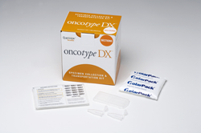

All specimens must be labeled with barcode labels from the Oncotype DX Specimen Collection and Transportation Kit Box for each patient.  Should you need to order Kit boxes, please [click here](https://online.genomichealth.com/ContactUs.aspx).

[Top](https://online.genomichealth.com/Help-HowToSubmitSpecimen.aspx)

**Materials and Equipment**

### Oncotype DX Specimen Kit containing the patient specimen, pathology report and Oncotype DX Requisition Form.

* FedEx® US Airbill pre-printed with Genomic Health shipping information.
* FedEx® Clinical Pak, Large – a plastic over wrap used to ship the specimen to Genomic Health.
* FedEx® adhesive airbill pouch for the FedEx Airbill.
* Seal the Clinical Pak by removing the plastic adhesive protector from the white strip and secure.
* Place the package in the designated FedEx® pickup location at your site.
* If your site does not have standard FedEx® pickup, call 800-GO FEDEX (800-463-3339) to arrange for pick up.

## Health Insurance Coverage

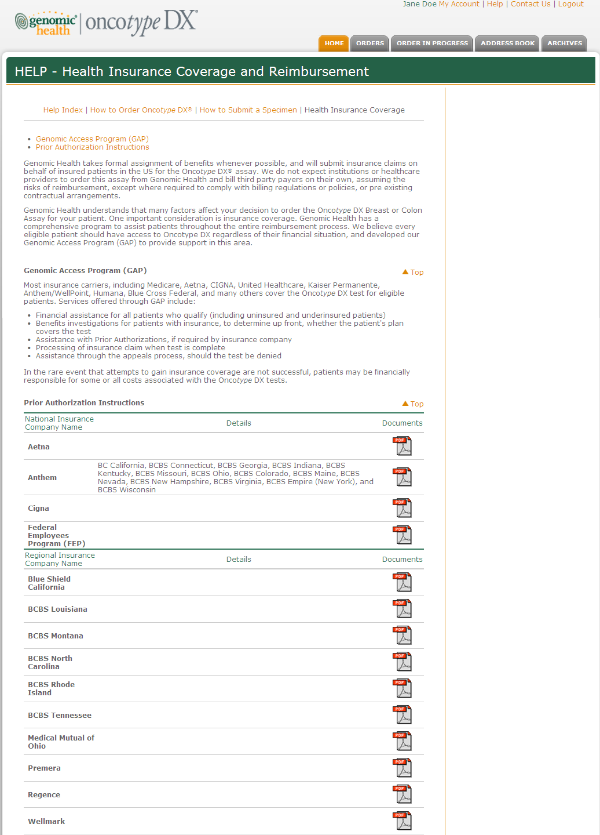

# Legal & Regulatory Requirements

|  |  |  |
| --- | --- | --- |
| **CONTENT**  **OWNERS** | **Department** | **Responsible Person** |
| Legal | Kathleen Determann |
| Clinical Laboratory – Regulatory | Stephanie Butler |
| **PURPOSE** | The user is required to agree to the “Terms of Use” statement before he/she is allowed to use the Portal website. | |

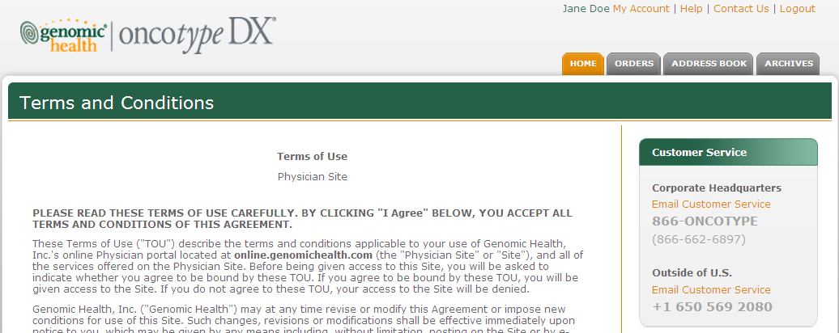

## Clinical Terms of Use (TOU)

**Terms of Use**

Physician Site

**PLEASE READ THESE TERMS OF USE CAREFULLY. BY CLICKING “I Agree” BELOW, YOU ACCEPT ALL TERMS AND CONDITIONS OF THIS AGREEMENT.**

These Terms of Use (“TOU”) describe the terms and conditions applicable to your use of Genomic Health, Inc.’s online Physician portal located at **online.genomichealth.com** (the “Physician Site” or “Site”), and all of the services offered on the Physician Site. Before being given access to this Site, you will be asked to indicate whether you agree to be bound by these TOU. If you agree to be bound by these TOU, you will be given access to the Site. If you do not agree to these TOU, your access to the Site will be denied.

Genomic Health, Inc. (“Genomic Health”) may at any time revise or modify this Agreement or impose new conditions for use of this Site. Such changes, revisions or modifications shall be effective immediately upon notice to you, which may be given by any means including, without limitation, posting on the Site or by e-mail. Any use of the Site by you after such notice shall be deemed to constitute acceptance of such changes, revisions or modifications. The most current version of the TOU can be reviewed by clicking on the “Terms of Use” hypertext link located at the bottom of each page of the Site. Genomic Health may modify its services at any time.

As described in these TOU, laboratory tests may only be “ordered” by, and results reported to qualified health care professionals (“physicians”). However, a physician may contact Genomic Health to designate an authorized representative (“delegate”), as appropriate under these TOU and all applicable laws in your jurisdiction. As used herein, delegate “requests” or “requisitions” refer to communications that facilitate a physician’s decision to “order” a laboratory test for a particular patient.

**Description of Services.**

This website is designed to provide online results with respect to our diagnostic testing services, documents and information related to these testing services, and online requisitions for test services. Through the Physician Site, Genomic Health provides you with access to patient laboratory results, test requisition documents, documents and information related to the laboratory test services, and the ability to send secure, authorized electronic correspondence. In the future, Genomic Health may also provide you with the ability to review requisition status, aggregate data from your patients, order specimen kits, and may also permit you to compare data relating to your patients with anonymous aggregated data of other patients (collectively, the “Services”). The Services, including any updates, enhancements, new features, and/or the addition of any new properties, are subject to these TOU. Genomic Health may also offer services from time to time that are governed by other contractual terms. In such cases those terms will be posted on the relevant service(s) to which they apply.

**Physician and Authorized Representative Responsibilities.**

*Confidentiality and Compliance with Laws.*

You agree and acknowledge that you will have access to confidential and personally identifiable health information on this Site and that your use of such information shall be in accordance with these TOU and all applicable privacy regulations and directives. You agree and acknowledge responsibility for obtaining patient full consent to provide his/her private health or financial information to Genomic Health in Redwood City, California as required by the data privacy laws in your jurisdiction. For U.S. users, this includes provisions of the federal privacy regulations and the federal security regulations issued pursuant to the Health Insurance Portability and Accountability Act of 1996 (“HIPAA”), and all applicable local, state, and federal laws and regulations, including but not limited to statutory and non-statutory guidelines that would apply to services that Genomic Health provides in accordance with these TOU.

*Member Account, Password, and Security.*

You will be provided with an account which is accessed by use of a personal password and username. You are responsible for maintaining the confidentiality of your password and account, and any and all activities that occur under your account. If at any time you forget your password, or would like to change your password, you may do so by clicking on the (Forgot your password?) which will prompt you to answer 3 security questions and allow you to reset your password information. It is your responsibility to change the password to your account on a regular basis. You agree to notify Genomic Health immediately of any unauthorized use of your account or any suspected breach of security.

To the extent permitted by applicable law, Genomic Health will not be liable for any loss that you may incur as a result of someone else using your password or account, either with or without your knowledge. You may be held liable for losses incurred by Genomic Health or another party due to someone else using your account or password. You may not use anyone else’s account at any time, with or without the permission of the account holder.

If you terminate your contract with Genomic Health you shall immediately cease using your access to the Site and will take appropriate steps (such as contacting our Support Center) to inform us that you are no longer entitled to access.

*Authorized Representatives (Delegates)*

You may be able to select authorized representatives (“delegates”) who are able to request testing services that you have ordered and/or access information, documents, and laboratory results relating to your practice. Each delegate will use his or her unique account and will be bound by this TOU. Some jurisdictions have limitations on who is qualified to request medical tests or access test results. You are responsible for selecting delegates that are qualified under all applicable regulations and statutes, and notifying Genomic Health of such selection. At your direction only, delegates may request test services that are appropriate for the patient, and your order of the laboratory test must be documented in the patient medical file.

You are responsible for the actions of your delegates and shall be held liable for losses incurred by Genomic Health or another party due to your delegates’ actions. You agree that any such delegate shall be acting at your direction and under your control and shall have rights to access the portal only as authorized by you. You are responsible for reviewing account information to determine that all delegate activity is appropriate and lawful, and notifying Genomic Health of any known violations of law or these TOU. Genomic Health will provide these delegates with patient test results on your behalf, and Genomic Health regards such delegates as acting as your authorized representative and working under your direction and in accordance and conformity with the laws and regulations applicable in your jurisdiction. Therefore, if you suspend or terminate your employment or other contractual relationship with any such delegate, you agree that it is your independent responsibility to immediately notify Genomic Health (such as using the delegate management page in the online physician portal) of that suspension or termination so that the individual’s access to the portal can be immediately disabled.

Delegates using this system agree that (1) they are currently employed by or under contract with the physician who ordered the test for the patients whose test results they are accessing, or work for a member of such patient’s clinical health care team; (2) that they have been personally authorized to access this physician portal by the physician(s) for whom they work; (3) that they are accessing or providing information only as directed, authorized and instructed by the physician(s) for whom they work; (4) that they will use and disclose the test results and other information obtained through this physician portal in accordance with applicable health care privacy laws,and in accordance with the policies regarding protected health information of their physician-employer; and that (5) they are accessing this portal using their own unique account.

**Delegates: Limitations of Use**

In addition to the terms set forth herein, you must comply with all applicable laws with regard to authorizing delegates to request tests and receive test results. Physicians in Florida and Maryland may only authorize delegates to request tests who are licensed practioners under the laws of those states. Physicians in New York and Pennsylvania may allow delegates to request tests only if they provide a written order signed by the ordering physician for all Medicaid patients. Physicians outside the United States must abide by all relevant local and international laws. You are responsible for obtaining guidance regarding compliance for all applicable laws in your jurisdiction. Genomic Health reserves the right to refuse any test requisitions or submissions of authorized delegates that it believes may be illegal or improper.

**Genomic Health Responsibilities.**

*Security.*

Information transmitted through the Physician Site is encrypted using industry standard Secure Sockets Layer (SSL) technology. Information is processed and stored on controlled servers with restricted access. Genomic Health will monitor usage of the Physician site and maintain usage audits and logs of all activity. If suspicious activity is found, Genomic Health has the right to suspend or terminate a user account.

*Accessibility.*

Genomic Health will take all reasonable steps to make the Physician Site available to authorized users seven (7) days per week, twenty-four (24) hours per day. Please note that the system may not be available at certain times due to system repair or maintenance. Genomic Health Customer Service is available 5:30am to 5:00pm PST Monday through Friday.

*Applicable Laws and Regulations.*

Genomic Health will comply with all applicable provisions of the federal privacy regulations, the federal security regulations issued pursuant to HIPAA, and all applicable local, state, federal, and foreign laws and regulations.

**Personal and Non-Commercial Use Limitation.**

The Physician Site and Services provided on this Site are protected by U.S. and foreign copyright, trade dress, trademark, unfair competition laws, and other applicable laws and regulations. Unless otherwise specified, the Physician Site and the Services are for the sole use of you and your delegates. Protected health information provided on the Physician Site, including reports, patient information, test requisition forms, and facsimile cover sheets, can be copied, distributed, transmitted, reproduced, or transferred by the physician for the sole purpose of treatment, payment, or healthcare operations and in accordance with the applicable data protection legislation.

**This Site Does Not Provide Legal or Medical Advice.**

The content on this Site is intended to be an information resource, and is provided solely on an “AS IS” and “AS AVAILABLE” basis. Genomic Health is not engaged in rendering medical or legal advice via this Site, and the information provided is not intended to be a substitute for consulting an attorney or obtaining professional medical advice, diagnosis, or treatment. Genomic Health does not recommend or endorse any specific physicians, products, procedures, opinions, or other information that may be mentioned on the Site. Reliance on any information provided by Genomic Health, employees of Genomic Health, others appearing on the Site at the invitation of Genomic Health, or other visitors to the Site, is solely at your own risk.

**Data Access and Privacy.**

Access to a patient’s results is limited to the patient’s physician, or the designated agent(s) (delegates) of such physician. Access to your patient’s specific data by a non-designated participating physician will only be permitted by Genomic Health, through the Physician site, if the data is de-identified consistent with HIPAA and/or applicable foreign data privacy laws.

See our Notice of Privacy Practices relating to the use and disclosure of patient results and personally identifiable health information. Genomic Health’s Notice of Privacy Practices, as it may change from time to time, applies to the use and disclosure of confidential and personally identifiable health information. The Notice of Privacy Practices is a part of these TOU and is incorporated herein by this [reference](http://www.genomichealth.com/FooterPages/PrivacyNotice.aspx?Source=online).

See our Privacy Statement relating to the collection and use of the personal information you or your delegates provide to us with your patient’s consent. Genomic Health’s Privacy Statement, as it may change from time to time, applies to the collection and use of your personal information. The Privacy Statement is a part of these TOU and is incorporated herein by this [reference](http://www.genomichealth.com/FooterPages/PrivacyStatement.aspx?Source=online).

**E-mail or Electronic Correspondence Communications**

If you choose to send us an e-mail message, we may retain the content of the e-mail, your e-mail address, and our response in order to service your needs.

Whenever you provide to us or we otherwise obtain your e-mail address within the context of our relationship, we may use that e-mail address to send you messages related to your accounts or services or other products or services that may be available to you. You can unsubscribe from some of these e-mail messages by contacting Customer Service. See E-mail Opt Out below for more details. Genomic Health, Inc. will not sell or distribute your E-mail address to third parties whether “websites” that are not involved with business with Genomic Health, Inc.

Please note that some Genomic Health, Inc. services or online programs Online Ordering require a valid e-mail address in order to register and/or continue use of the service. You will receive e-mail alerts or notification messages from these programs unless you un-enroll from these services. To learn more about these services and how to update your preferences, please contact Customer Service.

**E-mail Opt Out**

If you no longer wish to receive e-mail offers or solicitations from Genomic Health, Inc., you may unsubscribe by contacting Customer service at [customerservice@genomichealth.com](mailto:customerservice@genomichealth.com) or by calling 866-oncotype (866-662-6897).

If you opt out of e-mail solicitations, Genomic Health, Inc. reserves the right to contact you via e-mail to service and maintain your account relationship. For example, we may notify you about fraudulent activity on your account, respond to any customer inquiries or requests, or alert you to web site changes or outages.

**E-mail Tips**

Do not provide your e-mail address to third party web sites without reading the privacy and security policies and terms and conditions of these sites to ensure you understand the circumstances in which your e-mail address will be used.

If you suspect suspicious or fraudulent activity related to your account(s), please let your account provider know right away. You should also contact your Internet Service Provider so they may block suspicious messages from your e-mail inbox. To learn more about how to control and manage your incoming e-mails, please refer to your Internet Service Providers’ online resources. You may also visit the Federal Trade Commission’s web site on spam at <http://www.ftc.gov/spam>

**No Warranties.**

Genomic Health makes no representations about the suitability or accuracy of the information contained on the Physician Site, or provided under the Services for any purpose. ALL INFORMATION IS PROVIDED “AS IS” WITHOUT WARRANTY OF ANY KIND TO THE EXTENT PERMITTED BY APPLICABLE LAW. THE COMPANY AND/OR ITS RESPECTIVE SERVICE PROVIDERS HEREBY DISCLAIM ALL WARRANTIES AND CONDITIONS WITH REGARD TO THIS INFORMATION, INCLUDING ALL WARRANTIES AND CONDITIONS OF MERCHANTABILITY, WHETHER EXPRESS, IMPLIED OR STATUTORY, FITNESS FOR A PARTICULAR PURPOSE, TITLE AND NON-INFRINGEMENT TO THE EXTENT PERMITTED BY APPLICABLE LAW. GENOMIC HEALTH MAKES NO REPRESENTATIONS OR WARRANTIES THAT USE OF THE WEBSITE WILL BE UNINTERRUPTED OR ERROR-FREE. YOU ARE RESPONSIBLE FOR TAKING ALL NECESSARY PRECAUTIONS TO ENSURE THAT ANY CONTENT YOU OBTAIN FROM THE WEBSITE IS FREE OF VIRUSES AND MAINTAINED IN A SECURE MANNER.

The Physician Site and/or documents available in connection with the Services may include technical inaccuracies or typographical errors. Changes are periodically added to the information on the Physician Site and/or the TOU. Genomic Health and/or its respective suppliers may make improvements and/or changes in the Physician Site, Services or TOU at any time, without notice.

**Limitation of Liability.**

YOUR USE OF THIS SITE, ANY CONTENT ON THIS SITE, AND/OR THE SERVICES IS AT YOUR OWN RISK. TO THE EXTENT PERMITTED BY APPLICABLE LAW, GENOMIC HEALTH SPECIFICALLY DISCLAIMS ANY LIABILITY, WHETHER BASED IN CONTRACT, TORT, STRICT LIABILITY OR OTHERWISE, FOR ANY DIRECT, INDIRECT, INCIDENTAL, CONSEQUENTIAL, OR SPECIAL DAMAGES ARISING OUT OF OR IN ANY WAY CONNECTED WITH ACCESS TO OR USE OF THE WEBSITE OR THE SERVICES, EVEN IF GENOMIC HEALTH HAS BEEN ADVISED OF THE POSSIBILITY OF SUCH DAMAGES. IN NO EVENT SHALL GENOMIC HEALTH OR ITS RESPECTIVE SERVICE PROVIDERS BE LIABLE FOR ANY SPECIAL, INDIRECT OR CONSEQUENTIAL DAMAGES OR ANY DAMAGES WHATSOEVER RESULTING FROM LOSS OF USE, DATA OR PROFITS, WHETHER IN AN ACTION OF CONTRACT, NEGLIGENCE OR OTHER TORTIOUS ACTION, ARISING OUT OF OR IN CONNECTION WITH THE USE OF THE SITE OR THE SERVICES.

**No Unlawful or Prohibited Use.**

As a condition to your use of the Physician Site and the Services, you will not use either for any purpose that is unlawful or prohibited by these TOU. You may not allow delegates to use the Physician Site to request tests or view patient information in a manner that violates local, state or federal regulations. You may not use the Physician Site and the Services in any manner that could damage, disable, overburden, or impair any server for which Genomic Health is responsible, or the network(s) connected to those servers, or interfere with any other party’s use and enjoyment of the Physician Site or any Services. You may not attempt to gain unauthorized access to the Physician Site or any Services, other accounts, computer systems or networks connected to any of Genomic Health’s servers or to the Physician Site or any of the Services, through hacking, password mining or any other means. You may not obtain or attempt to obtain any materials or information through any means not intentionally made available through the Physician Site or the Services.

**Submissions Provided to Genomic Health or Posted on the Physician Site.**

By posting, uploading, inputting, providing or submitting e-mails, feedback or information (collectively “Submissions”), you are granting Genomic Health, its affiliated companies and necessary sublicensees permission to use your Submissions to the extent necessary to perform the Services described in these TOU. In case of Information constituting “personal data”, any processing and disclosure of such data to the above entities will be conducted in accordance with the applicable data protection laws.

If you have a prescribing or clinical inquiry concerning a particular patient, do not include any information for which you do not have all necessary patient consents or authorizations to disclose. When submitting clinical inquiries, patient identification, or other protected health information, use the secure submission tools available on the Physician Site.

Please note that Submissions by other means may not be secure. Please consider this fact before submitting e-mail to Genomic Health.

**Links to third party sites.**

There may be links within the Physician Site that will take you to websites operated by third parties, subject to their respective terms of use and privacy policies. The linked sites are not under the control of Genomic Health and Genomic Health is not responsible for the contents of any linked site or any link contained in a linked site, or any changes or updates to such sites. Genomic Health is not responsible for webcasting or any other form of transmission received from any linked site. The company is providing these links to you only as a convenience, and the inclusion of any link does not imply endorsement by the company of the site.

**Questions.**

If you have any questions about these TOU, please contact us [privacy@genomichealth.com](mailto:privacy@genomichealth.com) .

## YOU ACKNOWLEDGE THAT YOU HAVE READ GENOMIC HEALTH’S TOU AGREEMENT AND UNDERSTAND IT. BY PRESSING “I Agree” BELOW, YOU CONSENT TO BE BOUND BY THESE TOU.

## Non-Clinical Terms of Use (TOU)

**Terms of Use**

Online Site

**PLEASE READ THESE TERMS OF USE CAREFULLY. BY CLICKING “I Agree” BELOW, YOU ACCEPT ALL TERMS AND CONDITIONS OF THIS AGREEMENT.**

These Terms of Use (“TOU”) describe the terms and conditions applicable to your use of Genomic Health, Inc.’s online portal located at **online.genomichealth.com** (the “Online Site” or “Site”), and all of the services offered on the Online Site. Before being given access to this Site, you will be asked to indicate whether you agree to be bound by the terms of these TOU. If you agree to be bound by these TOU, you will be given access to the Site. If you do not agree to these TOU, your access to the Site will be denied.

Genomic Health, Inc. (“Genomic Health”) may at any time revise or modify this Agreement or impose new conditions for use of this Site. Such changes, revisions or modifications shall be effective immediately upon notice to you, which may be given by any means including, without limitation, posting on the Site or by e-mail. Any use of the Site by you after such notice shall be deemed to constitute acceptance of such changes, revisions or modifications. The most current version of the TOU can be reviewed by clicking on the “Terms and Conditions” hypertext link located at the bottom of each page of the Site. Genomic Health may modify its services at any time.

**Description of Services.**

This website is designed to provide secure access to documents and materials. Through the Online Site, Genomic Health may provide you with access to confidential documents and information. Genomic Health may also provide you with the ability to upload documents and send secure, authorized electronic correspondence (collectively, the “Services”). The Services, including any updates, enhancements, new features, and/or the addition of any new properties, are subject to these TOU. Genomic Health may also offer services from time to time that are governed by other contractual terms. In such cases those terms will be posted on the relevant service(s) to which they apply.

**Your Responsibilities.**

*Confidentiality and Compliance with Laws.*

You agree and acknowledge that you will have the ability to send and receive confidential information on this Site and that your use of such information shall be in accordance with these TOU and all applicable provisions of federal privacy regulations and the federal security regulations issued pursuant to the Health Insurance Portability and Accountability Act of 1996 (“HIPAA”), and all applicable local, state, federal, and international laws on data privacy, including but not limited to statutory and non-statutory guidelines that would apply to services that Genomic Health provides in accordance with these TOU.

*Member Account, Password, and Security.*

You will be provided with a unique account which is accessed by use of your personal password and username. “You are responsible for maintaining the confidentiality of your password and account, and any and all activities that occur under your account.” If at any time you forget your password, or would like to change your password, you may do so by clicking (Forgotten Password) which will prompt you to answer 3 security questions and enter your new password information. It is your responsibility to change the password to your account on a regular basis. You agree to notify Genomic Health immediately of any unauthorized use of your account or any suspected breach of security.

To the extent permitted by applicable law, Genomic Health will not be liable for any loss that you may incur as a result of someone else using your password or account, either with or without your knowledge. You may be held liable for losses incurred by Genomic Health or another party due to someone else using your account or password. You may not use anyone else’s account at any time, with or without the permission of the account holder, nor may you allow anyone else to use your account.

If you terminate your contract with Genomic Health you shall immediately cease using your access to the Site and will take appropriate steps (such as contacting our Support Center) to inform us that you are no longer entitled to access.

**Genomic Health Responsibilities.**

*Security.*

Information transmitted through the Online Site is encrypted using industry standard Secure Sockets Layer (SSL) technology. Information is processed and stored on controlled servers with restricted access. Genomic Health will monitor usage of the Online Site and maintain usage audits and logs of all activity. If suspicious activity is found, Genomic Health has the right to suspend or terminate a user account.

*Accessibility.*

Genomic Health will take all reasonable steps to make the Online Site available to authorized users seven (7) days per week, twenty-four (24) hours per day. Please note that the system may not be available at certain times due to system repair or maintenance. Genomic Health customer service is available 5:30am to 5:00pm PST Monday through Friday.

**Personal and Non-Commercial Use Limitation.**

The Online Site and Services provided on this Site are protected by U.S. and foreign copyright, trade dress, trademark, unfair competition laws, and other applicable laws and regulations. Unless otherwise specified, the Online Site and the Services are for the sole use of you and your facility.

**This Site Does Not Provide Legal or Medical Advice.**

The content on this Site is intended to be an information resource, and is provided solely on an “AS IS” and “AS AVAILABLE” basis. Genomic Health is not engaged in rendering legal or medical advice via this Site, and the information provided is not intended to be a substitute for professional legal counsel or medical advice, diagnosis, or treatment. Genomic Health does not recommend or endorse any specific products, procedures, opinions, or other information that may be mentioned on the Site. To the extent permitted by applicable law, reliance on any information provided by Genomic Health, employees of Genomic Health, others appearing on the Site at the invitation of Genomic Health, or other visitors to the Site, is solely at your own risk.

**Data Access and Privacy.**

See our Privacy Statement relating to the collection and use of personal information you provide to us with your patient’s consent. Genomic Health’s Privacy Statement, as it may change from time to time, applies to the collection and use of your personal information. The Privacy Statement is a part of these TOU and is incorporated herein by this [reference](http://www.genomichealth.com/FooterPages/PrivacyNotice.aspx?Source=online).

**E-mail or Electronic Correspondence Communications**

If you choose to send us an e-mail message, we may retain the content of the e-mail, your e-mail address, and our response in order to service your needs.

Whenever you provide to us or we otherwise obtain your e-mail address, we may use that e-mail address to send you messages related to your accounts or services or other products or services that may be available to you. You can unsubscribe from some of these e-mail messages by contacting Customer Service. See E-mail Opt Out below for more details. Genomic Health, Inc. will not sell or distribute your E-mail address to third parties whether “websites” that are not involved with business with Genomic Health, Inc.

Please note that some Genomic Health, Inc. services or online programs Online Ordering require a valid e-mail address in order to register and/or continue use of the service. You will receive e-mail alerts or notification messages from these programs unless you un-enroll from these services. To learn more about these services and how to update your preferences, please contact Customer Service.

**E-mail Opt Out**

If you no longer wish to receive e-mail offers or solicitations from Genomic Health, Inc., you may unsubscribe by contacting Customer service at [customerservice@genomichealth.com](mailto:customerservice@genomichealth.com) or by calling 866-ONCO*TYPE* (866-662-6897).

If you opt out of e-mail solicitations, Genomic Health, Inc. reserves the right to contact you via e-mail to service and maintain your account relationship. For example, we may notify you about fraudulent activity on your account, respond to any customer inquiries or requests, or alert you to web site changes or outages.

**E-mail Tips**

Do not provide your e-mail address to third party web sites without reading the privacy and security policies and terms and conditions of these sites to ensure you understand the circumstances in which your e-mail address will be used.

If you suspect suspicious or fraudulent activity related to your account(s), please let your account provider know right away. You should also contact your Internet Service Provider so they may block suspicious messages from your e-mail inbox. To learn more about how to control and manage your incoming e-mails, please refer to your Internet Service Providers’ online resources. You may also visit the Federal Trade Commission’s web site on spam at <http://www.ftc.gov/spam>

**No Warranties.**

Genomic Health makes no representations about the suitability or accuracy of the information contained on the Online Site, or provided under the Services for any purpose. ALL INFORMATION IS PROVIDED “AS IS” WITHOUT WARRANTY OF ANY KIND. TO THE EXTENT PERMITTED BY APPLICABLE LAW, THE COMPANY AND/OR ITS RESPECTIVE SERVICE PROVIDERS HEREBY DISCLAIM ALL WARRANTIES AND CONDITIONS WITH REGARD TO THIS INFORMATION, INCLUDING ALL WARRANTIES AND CONDITIONS OF MERCHANTABILITY, WHETHER EXPRESS, IMPLIED OR STATUTORY, FITNESS FOR A PARTICULAR PURPOSE, TITLE AND NON-INFRINGEMENT. GENOMIC HEALTH MAKES NO REPRESENTATIONS OR WARRANTIES THAT USE OF THE WEBSITE WILL BE UNINTERRUPTED OR ERROR-FREE. YOU ARE RESPONSIBLE FOR TAKING ALL NECESSARY PRECAUTIONS TO ENSURE THAT ANY CONTENT YOU OBTAIN FROM THE WEBSITE IS FREE OF VIRUSES AND MAINTAINED IN A SECURE MANNER.

The Online Site and/or documents available in connection with the Services may include technical inaccuracies or typographical errors. Changes are periodically added to the information on the Online Site and/or the TOU. Genomic Health and/or its respective suppliers may make improvements and/or changes in the Online Site, Services or TOU at any time, without notice.

**Limitation of Liability.**

YOUR USE OF THIS SITE, ANY CONTENT ON THIS SITE, AND/OR THE SERVICES IS AT YOUR OWN RISK. TO THE EXTENT PERMITTED BY APPLICABLE LAW, GENOMIC HEALTH SPECIFICALLY DISCLAIMS ANY LIABILITY, WHETHER BASED IN CONTRACT, TORT, STRICT LIABILITY, CRIMINAL, OR OTHERWISE, FOR ANY DIRECT, INDIRECT, INCIDENTAL, CONSEQUENTIAL, OR SPECIAL DAMAGES ARISING OUT OF OR IN ANY WAY CONNECTED WITH ACCESS TO OR USE OF THE WEBSITE OR THE SERVICES, EVEN IF GENOMIC HEALTH HAS BEEN ADVISED OF THE POSSIBILITY OF SUCH DAMAGES. IN NO EVENT SHALL GENOMIC HEALTH OR ITS RESPECTIVE SERVICE PROVIDERS BE LIABLE FOR ANY SPECIAL, INDIRECT OR CONSEQUENTIAL DAMAGES OR ANY DAMAGES WHATSOEVER RESULTING FROM LOSS OF USE, DATA OR PROFITS, WHETHER IN AN ACTION OF CONTRACT, NEGLIGENCE OR OTHER TORTIOUS ACTION, ARISING OUT OF OR IN CONNECTION WITH THE USE OF THE SITE OR THE SERVICES.

**No Unlawful or Prohibited Use.**

As a condition to your use of the Online Site and the Services, you will not use either for any purpose that is unlawful or prohibited by these TOU. You may not use the Online Site and the Services in any manner that could damage, disable, overburden, or impair any server for which Genomic Health is responsible, or the network(s) connected to those servers, or interfere with any other party’s use and enjoyment of the Online Site or any Services. You may not attempt to gain unauthorized access to the Online Site or any Services, other accounts, computer systems or networks connected to any of Genomic Health’s servers or to the Online Site or any of the Services, through hacking, password mining or any other means. You may not obtain or attempt to obtain any materials or information through any means not intentionally made available through the Online Site or the Services.

**Submissions Provided to Genomic Health or Posted on the Online Site.**

By posting, uploading, inputting, providing or submitting e-mails, feedback or information (collectively “Submissions”), you are granting Genomic Health, its affiliated companies and necessary sublicensees permission to use your Submissions to the extent necessary to perform the Services described in these TOU. In case of Information qualified as “personal data”, any processing and disclosure of such data to the above entities will be conducted in accordance with the applicable data protection laws.

**Links to third party sites.**

There may be links within the Online Site that will take you to websites operated by third parties, subject to their respective terms of use and privacy policies. The linked sites are not under the control of Genomic Health and Genomic Health is not responsible for the contents of any linked site or any link contained in a linked site, or any changes or updates to such sites. Genomic Health is not responsible for webcasting or any other form of transmission received from any linked site. The company is providing these links to you only as a convenience, and the inclusion of any link does not imply endorsement by the company of the site.

**Questions.**

If you have any questions about these TOU, please contact us [privacy@genomichealth.com](mailto:privacy@genomichealth.com).

**YOU ACKNOWLEDGE THAT YOU HAVE READ GENOMIC HEALTH’S TOU AGREEMENT AND UNDERSTAND IT. BY PRESSING “I Agree” BELOW, YOU CONSENT TO BE BOUND BY THESE TOU**

## Delegate Attestation

In addition to the Terms of Use, Delegates must also review and agree to the Delegate Attestation shown below:

**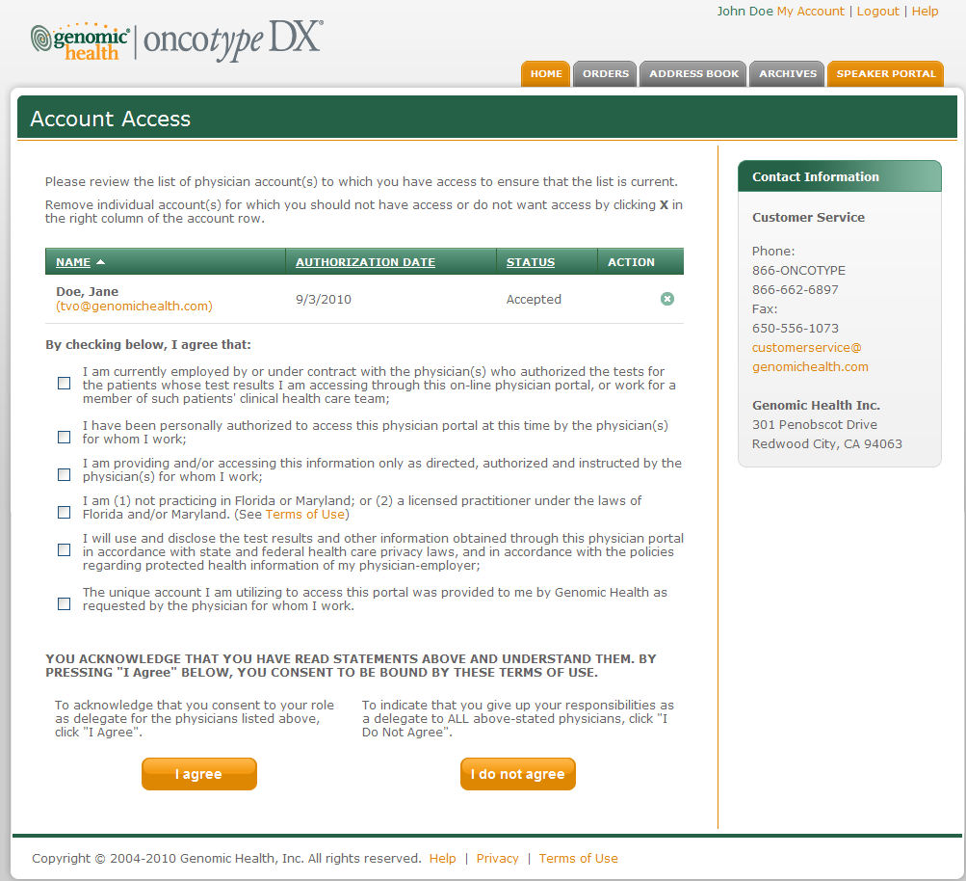**

## Physician’s Electronic Signature

The Physician Signature section on the Review page of online ordering will contain the following verbiage:

**Please read the statements below. When you are ready to place the test request, check the box and click the “Place Order” button.**

### Breast - DCIS

By selecting “Place Order” you are certifying the following: (1) with respect to tests reimbursed by Medicare, Medicaid or other third party payers, the test is medically necessary and the results will be used in the management of the patient; (2) If the ordering physician is not the treating physician (or his/her authorized representative), the ordering physician confirms that the treating physician has ordered the Onco*type* DX assay for this purpose; (3) the treating physician has obtained the patient’s consent for GHI to send the patient’s test results to the patient’s third party payer in connection with an appeal of a reimbursement denial or other reimbursement matter, if GHI has made prior attempts to obtain reimbursement without the release of such tests results; (4) the patient meets the criteria defined in the breast assay section below unless otherwise indicated in the Exception Criteria field.

**Exception Criteria**   
[Text box: Must be no longer than 240 characters.]

If GHI determines that the specimen does not fit the criteria stated in the applicable assay criteria section below, the patient’s test report will indicate, where appropriate, that the clinical interpretation of the assay result is unknown or adjusted. In all cases, it is the treating physician’s responsibility to determine whether and how the assay should be used in determining a treatment plan for that patient.

GHI will run the assay and report a result unless it determines that the specimen does not have adequate cancer tissue or if it determines that the order provides insufficient information to perform and report a result.

In some cases additional assessment methods, including confirmatory testing of HER2 status, may be used to verify that the specimen meets the criteria for the Onco*type* DX assay.

Oncotype DX Breast Cancer Assay Criteria

1. Ductal Carcinoma In Situ patients

If you select “Place Order”, no exception criteria have been entered, you attest that the specimen is from a newly diagnosed female patient with DCIS (Stage 0: Tis,N0, M0)

To review all information / instructions on how to order Onco*type* DX, please see [Help](file:///C:\\Documents%20and%20Settings\\czambo\\Local%20Settings\\Temporary%20Internet%20Files\\Content.Outlook\\Help-HowToOrder.aspx).

**[Check box – no change] I have read and agree to the above statements. If my patient falls outside of the specimen criteria for Onco*type* DX, I have supplied the exception criteria in the field provided. Checking this box andclicking “Place Order” constitutes my electronic signature and my consent to sign this request pursuant to the Terms of Use.** Agreement is required to proceed

### Breast - Invasive

By selecting “Place Order” you are certifying the following: (1) with respect to tests reimbursed by Medicare, Medicaid or other third party payers, the test is medically necessary and the results will be used in the management of the patient; (2) If the ordering physician is not the treating physician (or his/her authorized representative), the ordering physician confirms that the treating physician has ordered the Onco*type* DX assay for this purpose; (3) the treating physician has obtained the patient’s consent for GHI to send the patient’s test results to the patient’s third party payer in connection with an appeal of a reimbursement denial or other reimbursement matter, if GHI has made prior attempts to obtain reimbursement without the release of such tests results; (4) the patient meets the criteria defined in the breast assay section below unless otherwise indicated in the Exception Criteria field.

**Exception Criteria**   
[Text box: Must be no longer than 240 characters.]

If GHI determines that the specimen does not fit the criteria stated in the applicable assay criteria section below, the patient’s test report will indicate, where appropriate, that the clinical interpretation of the assay result is unknown or adjusted. In all cases, it is the treating physician’s responsibility to determine whether and how the assay should be used in determining a treatment plan for that patient.

GHI will run the assay and report a result unless it determines that the specimen does not have adequate cancer tissue or if it determines that the order provides insufficient information to perform and report a result.

In some cases additional assessment methods, including confirmatory testing of HER2 status, may be used to verify that the specimen meets the criteria for the Onco*type* DX assay.

ER Status:

The submitted specimen must be estrogen receptor positive (ER+) by either the IHC method used by a referring laboratory or the quantitative RT-PCR method, used by GHI. If GHI determines that the submitted specimen is not ER+ by either method, a RS will not be reported, and the patient / payer will not be billed. The specimen is assumed to be ER+ if no selection is made.

Node Status:

The nodal status is required to determine the extent of the clinical experience information to be included in the report for your patient. If the nodal status is not provided, a report with clinical experience for both node negative and node positive specimens will be sent. Additionally, the node status may be required for payor coverage determinations. If the nodal status is not specified, GHI may use the pathology report, if provided, to determine the nodal status for reimbursement purposes.

Oncotype DX Breast Cancer Assay Criteria

1. Invasive Breast Cancer patients

If you select “Place Order”, no exception criteria have been entered, and the completed specimen criteria fields do not indicate otherwise, you attest that the specimen is from a newly diagnosed female patient with Stage I, II, or III (T3, N1) ER positive breast cancer.

To review all information / instructions on how to order Onco*type* DX, please see [Help](file:///C:\\Documents%20and%20Settings\\czambo\\Local%20Settings\\Temporary%20Internet%20Files\\Content.Outlook\\Help-HowToOrder.aspx).

**[Check box – no change] I have read and agree to the above statements. If my patient falls outside of the specimen criteria for Onco*type* DX, I have supplied the exception criteria in the field provided. Checking this box andclicking “Place Order” constitutes my electronic signature and my consent to sign this request pursuant to the Terms of Use.** Agreement is required to proceed

### Colon

By selecting “Place Order” you are certifying the following: (1) with respect to tests reimbursed by Medicare, Medicaid or other third party payers, the test is medically necessary and the results will be used in the management of the patient; (2) If the ordering physician is not the treating physician (or his/her authorized representative), the ordering physician confirms that the treating physician has ordered the Onco*type* DX assay for this purpose; (3) the treating physician has obtained the patient’s consent for GHI to send the patient’s test results to the patient’s third party payer in connection with an appeal of a reimbursement denial or other reimbursement matter, if GHI has made prior attempts to obtain reimbursement without the release of such tests results; (4) the patient meets the criteria defined in the colon assay section below unless otherwise indicated in the Exception Criteria field.

**Exception Criteria**

[Text box: Must be no longer than 240 characters.]

If GHI determines that the specimen does not fit the criteria stated in the applicable assay criteria section below, the patient’s test report will indicate, where appropriate, that the clinical interpretation of the assay result is unknown or adjusted. In all cases, it is the treating physician’s responsibility to determine whether and how the assay should be used in determining a treatment plan for that patient.

GHI will run the assay and report a result unless it determines that the specimen does not have adequate cancer tissue or if it determines that the order provides insufficient information to perform and report a result.

Oncotype DX Colon Cancer Assay Criteria

1. If you select “Place Order”, no exception criteria have been entered, and the completed specimen criteria fields do not indicate otherwise, you attest that the specimen is from a newly diagnosed Stage II colon cancer patient with adenocarcinoma or mucinous carcinoma.

To review all information / instructions on how to order Onco*type* DX, please see [Help](file:///C:\\Documents%20and%20Settings\\czambo\\Local%20Settings\\Temporary%20Internet%20Files\\Content.Outlook\\Help-HowToOrder.aspx).

**[Check box – no change] I have read and agree to the above statements. If my patient falls outside of the specimen criteria for Onco*type* DX, I have supplied the exception criteria in the field provided. Checking this box andclicking “Place Order” constitutes my electronic signature and my consent to sign this request pursuant to the Terms of Use.** Agreement is required to proceed

# Other Requirements

## Standard Operating Procedures

The following SOPs may need to be updated due to changes in Portal software for this release.

|  |  |
| --- | --- |
| **Document Number** | **Document Name** |
| SOP-OP-PA-03-001 | Requisition Processing |
| SOP-OP-PA-03-019 | Online Ordering Requisition Processing |
| SOP-CO-GA-02-007 | Approval and Use of Promotional, Public, and Competitive Statements |

## Training

Training will be provided to all applicable parties.

## User Testing and User Acceptance Testing

User Acceptance Testing is performed as a “smoke test” on the Production system after deployment of a new version of Portal software. Appropriate participants are selected based on the changes made to the Portal software.

# Appendix A – Portal Release History

|  |  |  |  |
| --- | --- | --- | --- |
| **Req. #** | **Requested Requirement** | **Priority** | **Target Release** |
| 1 | **Commercial Oldenburg Release**  The following features are included in the Oldenburg release:   * Ability to save in progress orders * Designate testing order when multiple primaries are submitted * Designate ER status for breast specimens * Retrieve user name and password * Removal of button to fax in insurance information * Applicable changes to the Help Page | 1 | 23-May-2010 |
| 2 | **Commercial Prague Release**  The following features are included in the Prague release:   * Applicable changes to the Delegate Attestation and Terms of Use * A change to the announcements page * Retirement of user requirement to enter Insurance address information * Inclusion of an instructional video entitled “Placing an Online Order” | 1 | 11-Sept-2010 |
| 3 | **Commercial Tel-Aviv**   * International Online Ordering. * Order Req PDF v13 Domestic * Display of dates and time in user specific format. * Revision of security question options * Changes to ER and multiple primaries options. | 1 | 17-Jan-2011 |
| 4 | **Commercial Tokyo**   * Enable online ordering for Japan, Greece, and Venezuela. | 1 | April-2011 |
| 5 | **Commercial Mercury**  Provide customers with the option to order MMR & DCIS. | 1 | Oct - 2011 |